Task 1: Enable CloudTrail Monitoring and Store Events in S3 and CloudWatch Logs
Objective
Enable AWS CloudTrail to monitor all AWS account activities and store the logs in both an S3 bucket and CloudWatch Logs for auditing, monitoring, and troubleshooting purposes.

Architecture
AWS Resources
|
v
AWS CloudTrail
|
+------------------+
| |
v v
S3 Bucket CloudWatch Logs
(Log Storage) (Real-Time Monitoring)

Step 1: Login to AWS Console
- Sign in to AWS Management Console.
- Search for CloudTrail in the AWS search bar.
- Open the CloudTrail service.

Step 2: Create a New Trail
- In CloudTrail Dashboard, click Trails.
- Click Create Trail.
Trail Configuration
Setting | Value
Trail Name | cloudtrail-monitoring
Storage Location | Create New S3 Bucket
Apply Trail to All Regions | Yes
Example:
Trail Name:
cloudtrail-monitoring 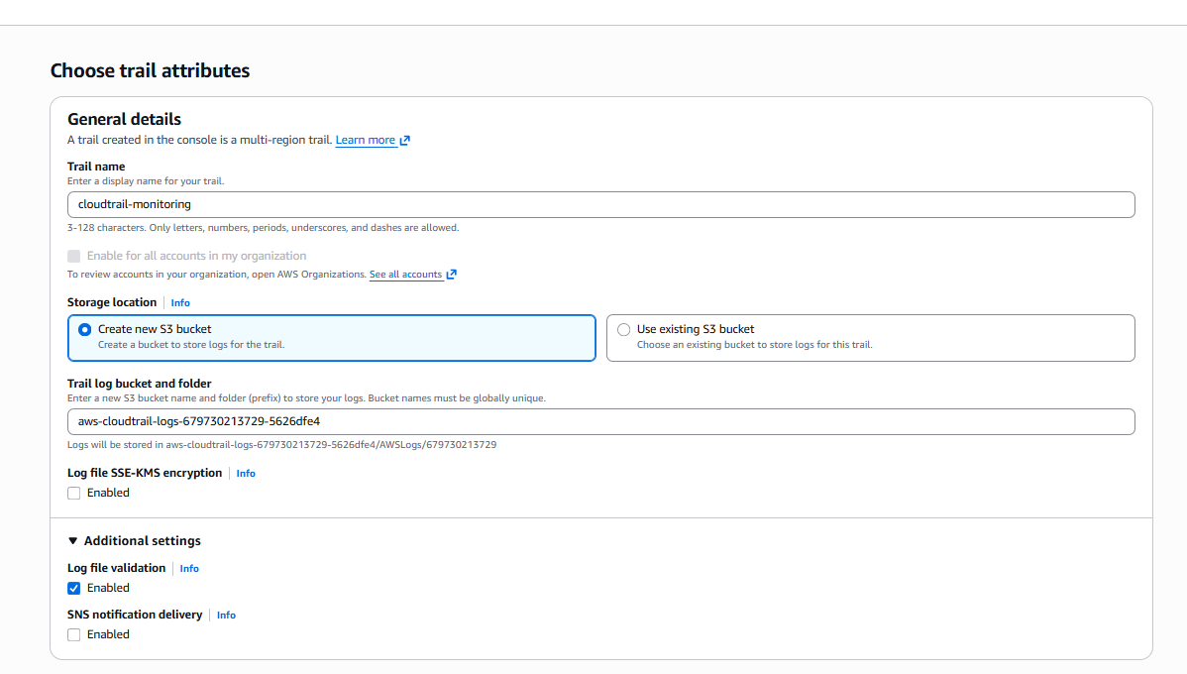
Step 2: Configure Trail Attributes
Configured the following settings:
Parameter | Value
Trail Name | cloudtrail-monitoring
Trail Type | Multi-Region Trail
Storage Location | New S3 Bucket
Log File Validation | Enabled
SNS Notifications | Disabled
A new S3 bucket was automatically created:
aws-cloudtrail-logs-679730213729-5626dfe4

Step 4: Enable Log File Validation
Under Additional Settings:
Check:
Enable Log File Validation
Purpose:
- Detects log tampering
- Ensures log integrity
- Useful for auditing

Step 5: Enable CloudWatch Logs
Scroll down to:
CloudWatch Logs
Select:
Enabled
Create New Log Group
Choose:
New
Example:
Log Group Name:
CloudTrail-Logs

Step 6: Create IAM Role for CloudWatch
CloudTrail needs permission to write logs into CloudWatch.
Click:
Create New IAM Role
Example Role Name:
CloudTrail_CloudWatch_Role
AWS automatically attaches the required permissions. 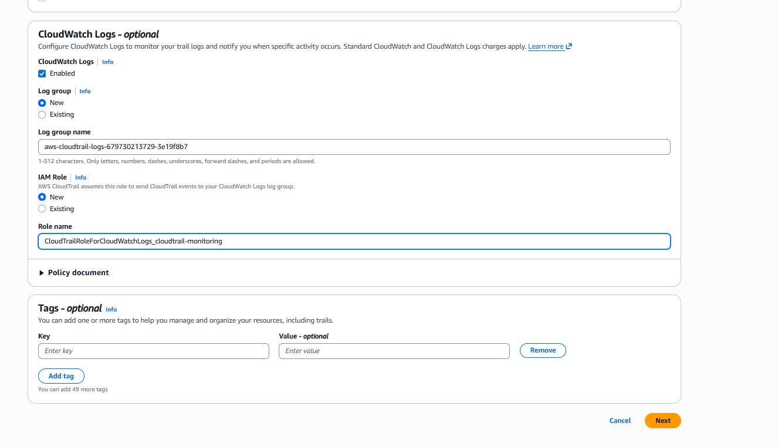

Step 7: Select Event Types
Choose: 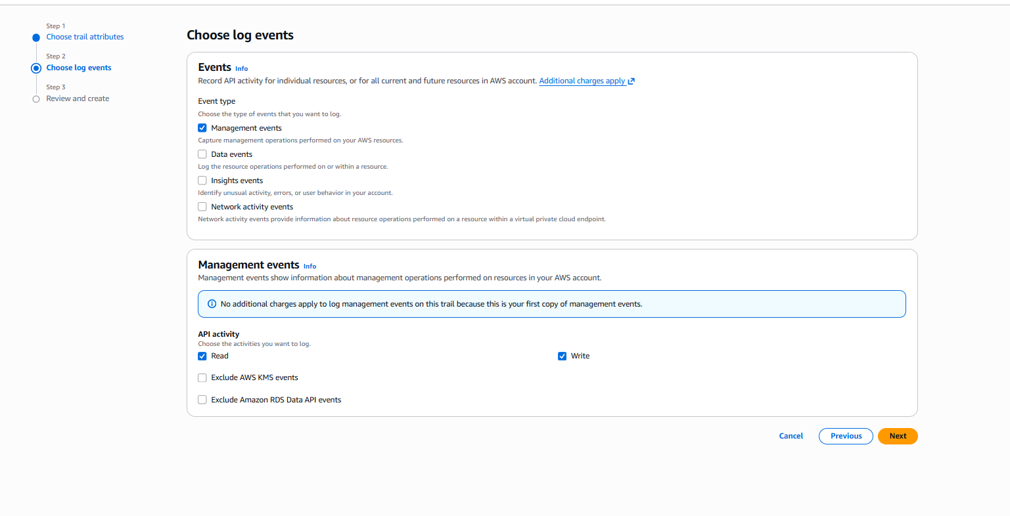
Management Events
Enable:
Read Events
Write Events
Examples:
- Create Bucket
- Delete Bucket
- Launch EC2
- Stop EC2
Leave Data Events and Insights Events disabled unless specifically required.

Step 8: Review and Create
Review all settings.
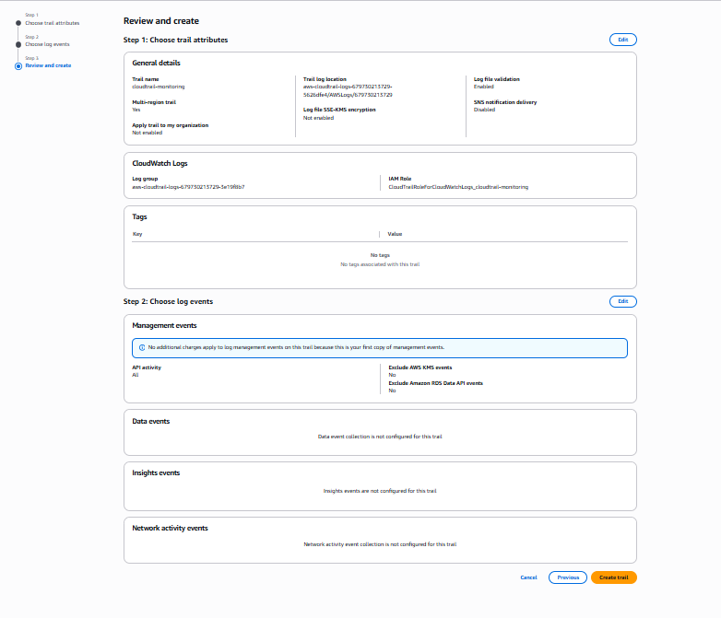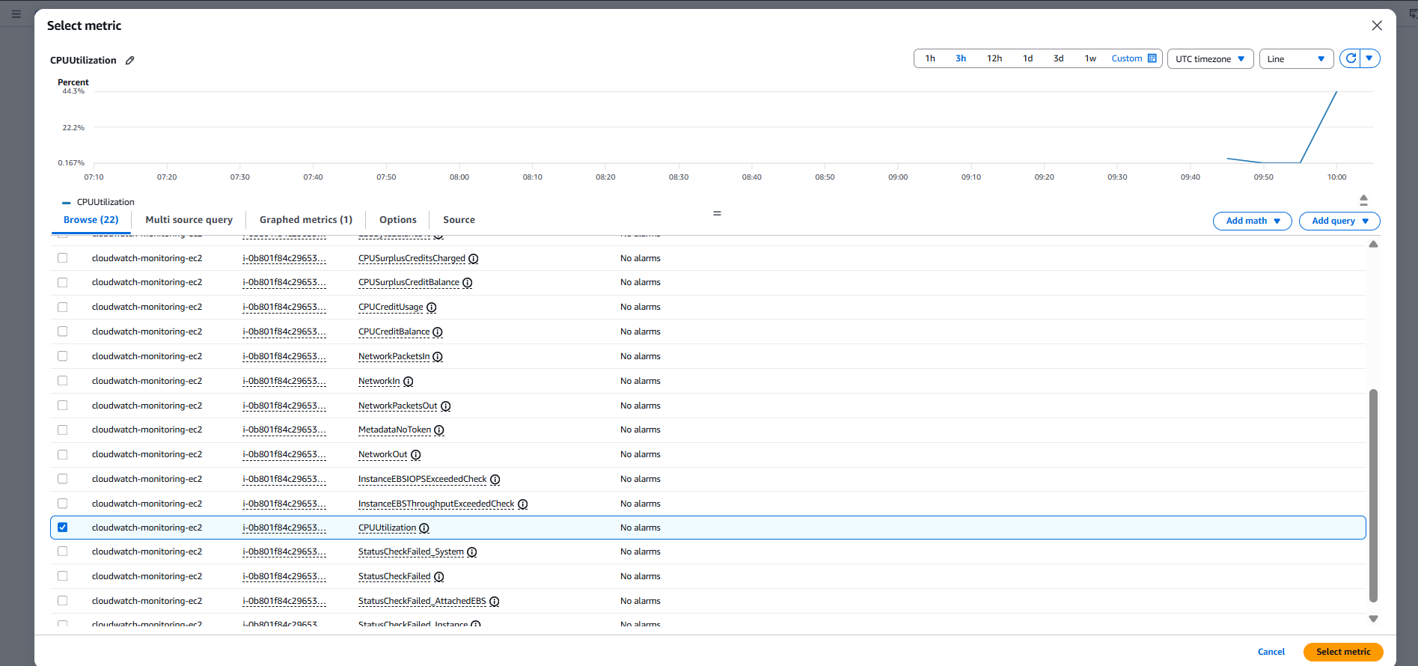
CloudTrail is now enabled. 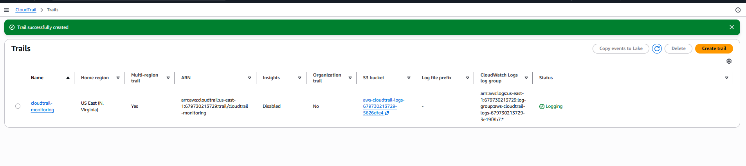

Step 9: Verify S3 Log Storage
- Open S3 Service.
- Open the bucket created earlier.
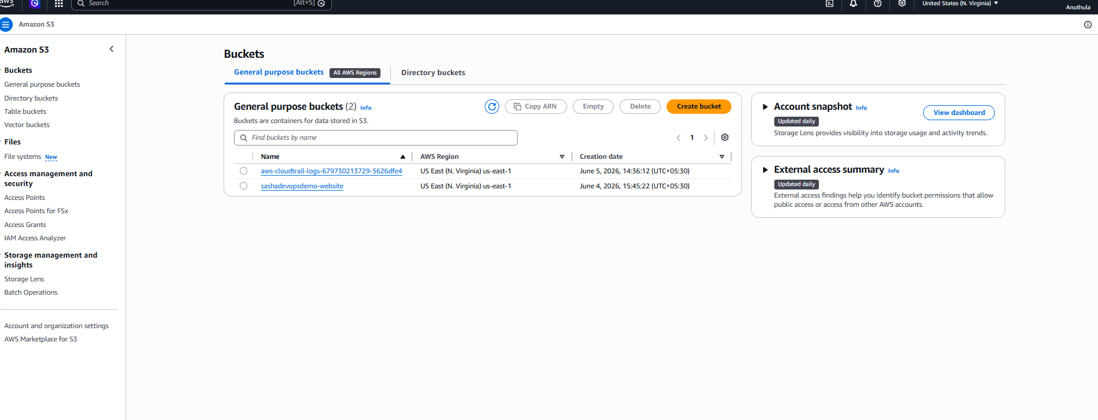Navigate to:
AWSLogs
└── Account-ID
└── CloudTrail
You will find CloudTrail log files stored here. 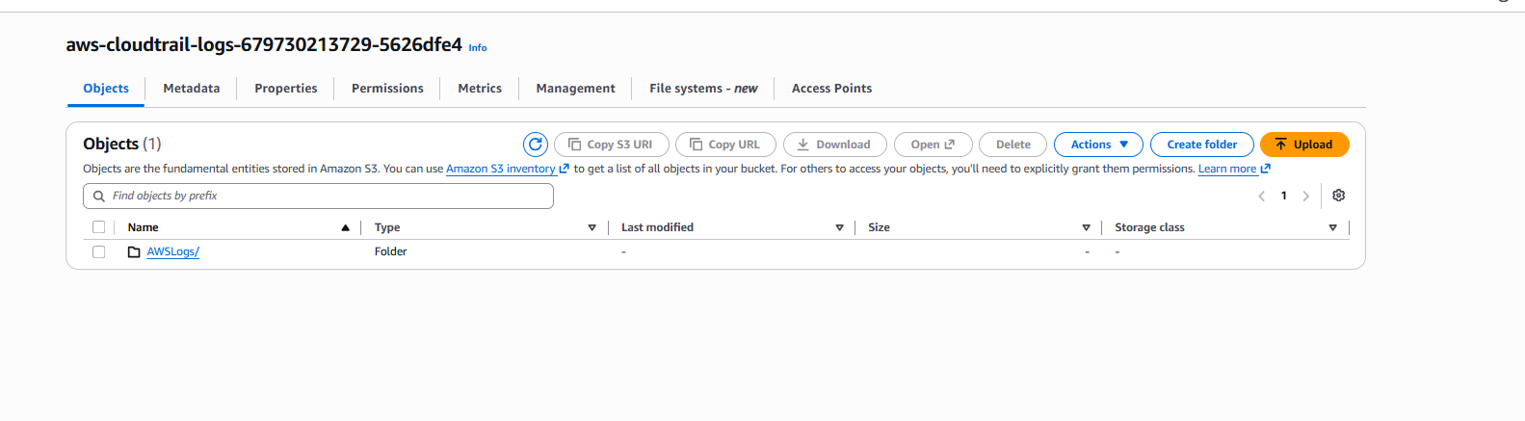 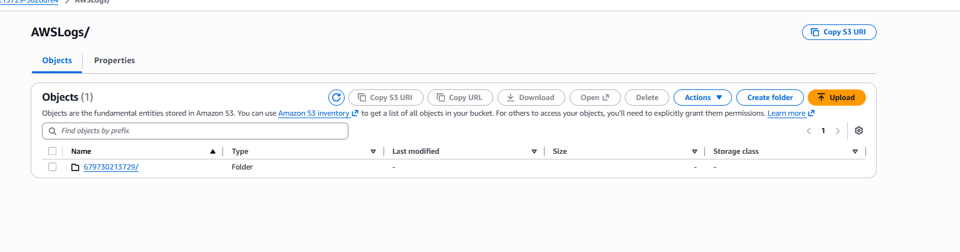 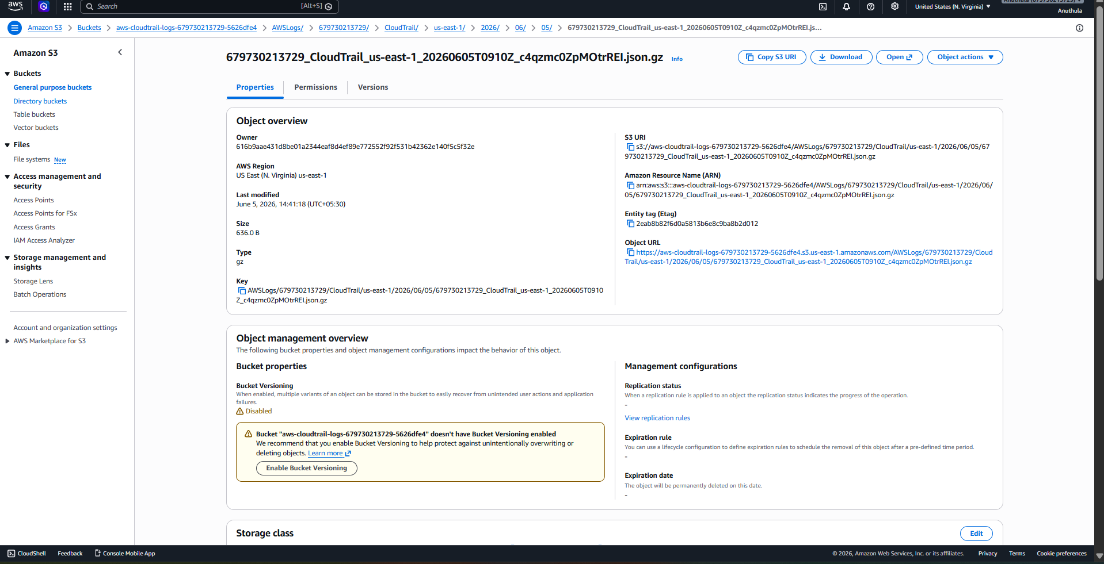 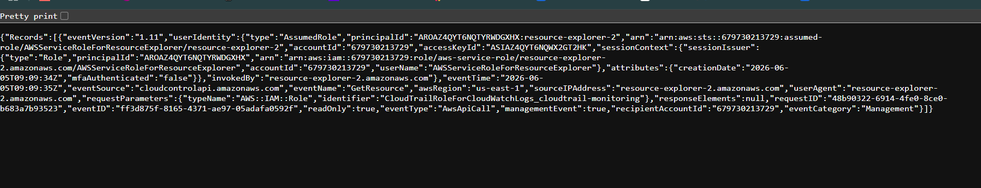

Step 10: Verify CloudWatch Logs
- Open CloudWatch.
- Click Log Groups.
- Open:
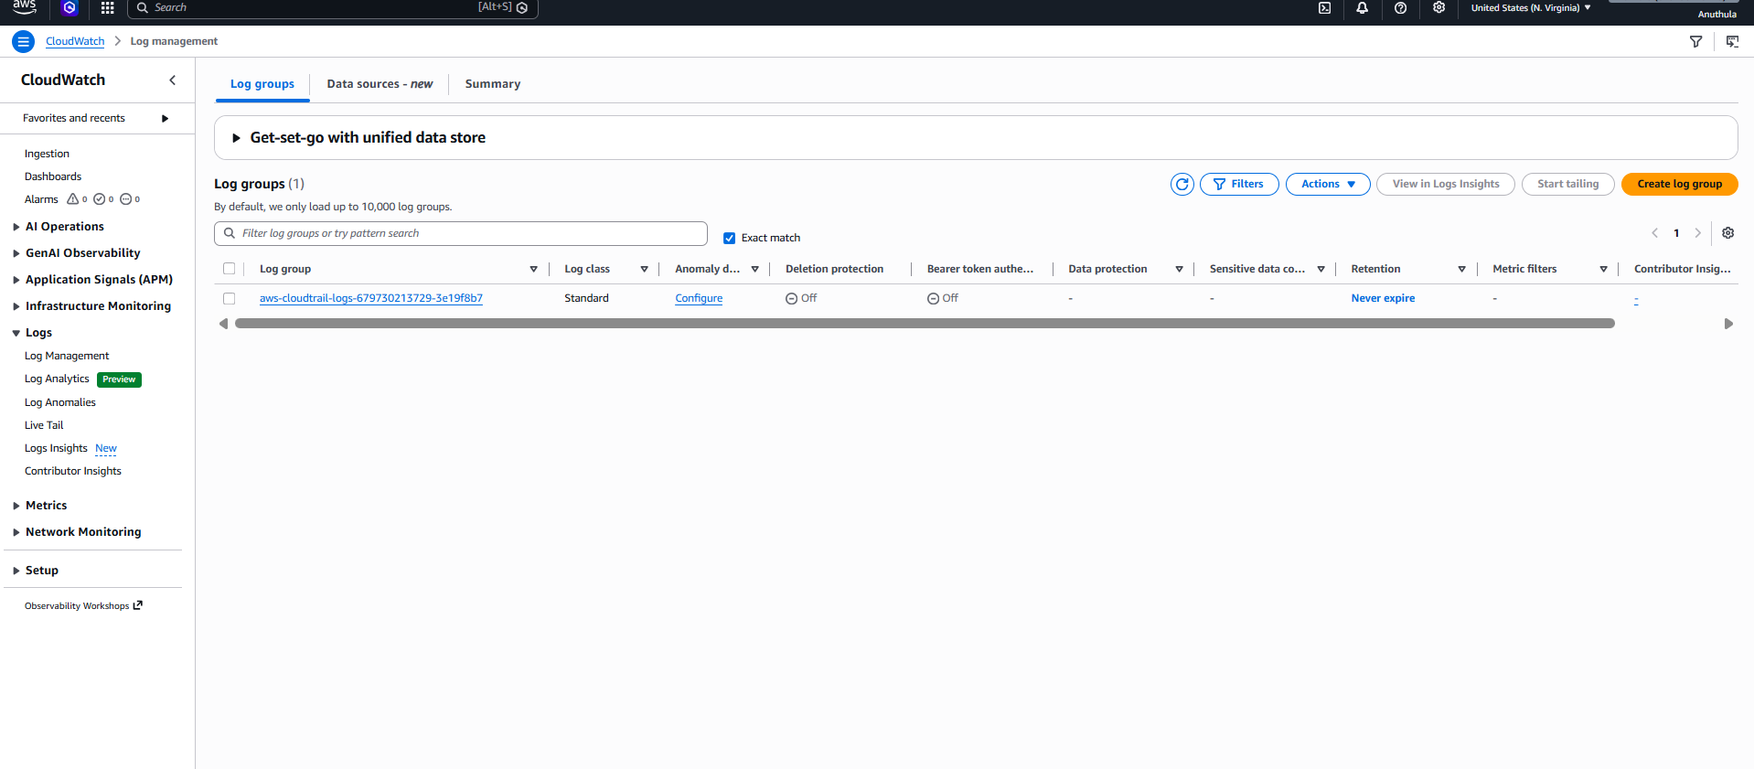
CloudTrail-Logs
You can view all CloudTrail events in real time.
Examples:
CreateBucket
DeleteBucket
RunInstances
StopInstances

Step 11: Test CloudTrail
Create an S3 Bucket
- Open S3.
- Create a bucket.
Example:
test-cloudtrail-bucket
Verify Event
Open:
CloudTrail
→ Event History
You should see:
CreateBucket
event recorded.

Expected Result
After successful configuration:
- CloudTrail monitors all AWS account activities.
- Logs are stored in an S3 bucket.
- Logs are sent to CloudWatch Logs.
- Event history is available for auditing.
- Real-time monitoring and troubleshooting are enabled.

Services Used
- AWS CloudTrail
- Amazon S3
- Amazon CloudWatch Logs
- IAM Role

Conclusion
Successfully enabled AWS CloudTrail monitoring and configured it to store event logs in both Amazon S3 and CloudWatch Logs. This setup provides centralized auditing, security monitoring, compliance tracking, and troubleshooting capabilities for AWS resources.

Task 2: Enable SNS for CloudTrail to Send Alerts via Email
Objective
The objective of this task is to configure Amazon Simple Notification Service (SNS) with AWS CloudTrail so that email notifications are automatically sent whenever CloudTrail delivers log files. This helps administrators monitor CloudTrail activity and receive alerts without manually checking AWS services.

Step 1: Create an SNS Topic
- Logged in to the AWS Management Console.
- Searched for and opened Amazon SNS.
- Clicked Create Topic.
- Selected Standard Topic as the topic type.
- Entered the topic name:
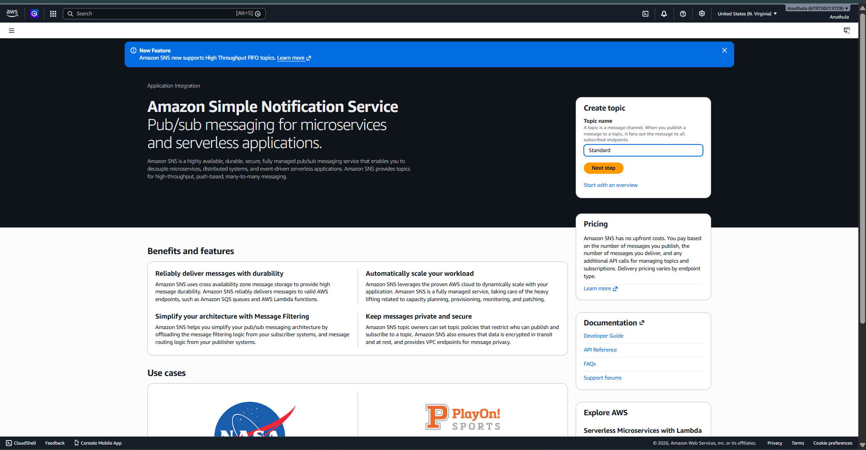

- 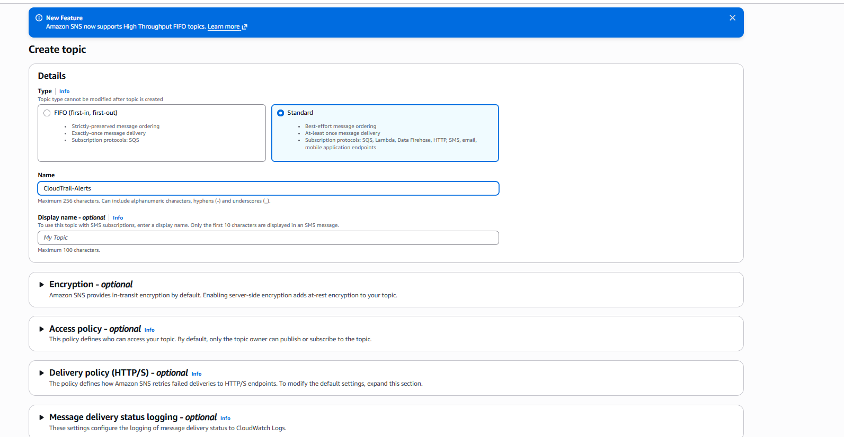 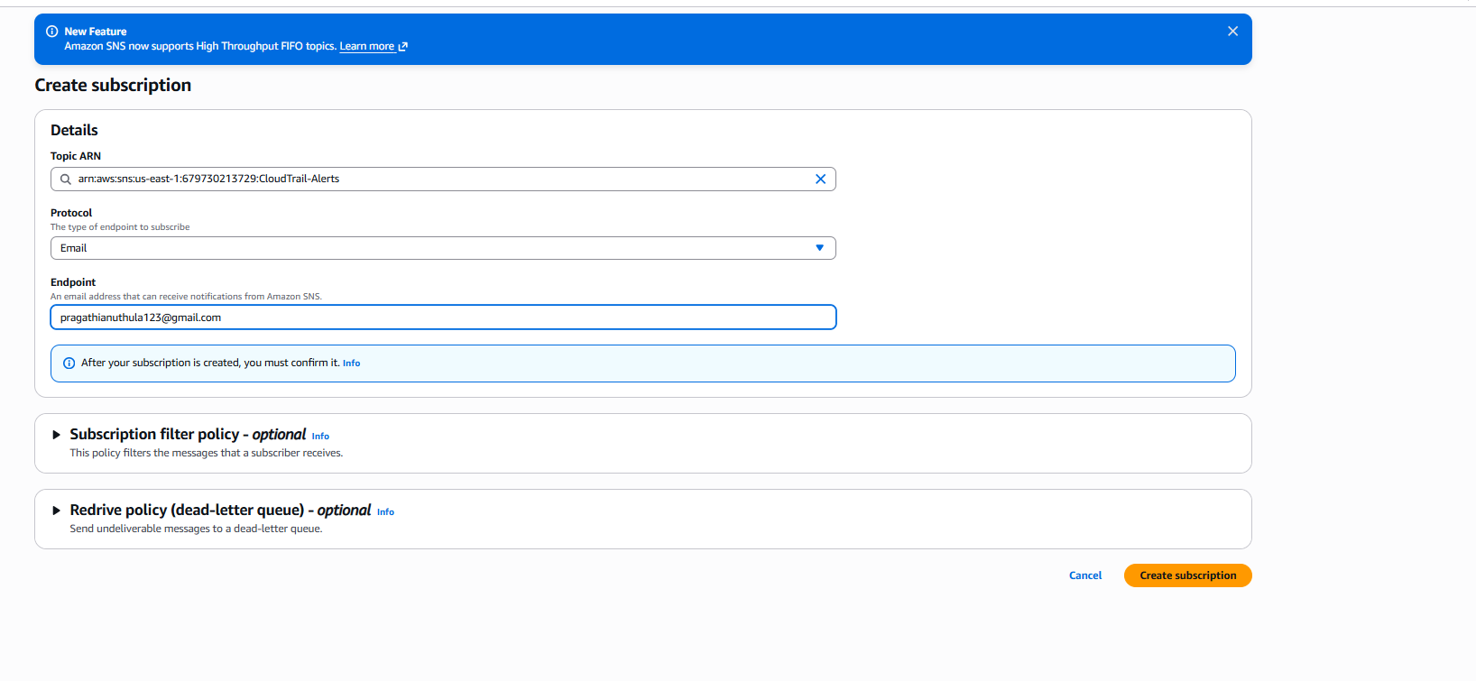 Entered the topic name:
CloudTrail-Alerts
- Kept all other settings as default.
- Clicked Create Topic.
Purpose
An SNS Topic acts as a communication channel that receives notifications from AWS services and forwards them to subscribers such as email addresses.
Step 2: Create an Email Subscription
- Opened the SNS topic CloudTrail-Alerts.
- Clicked Create Subscription.
- Selected the protocol:
Email
- Entered the email address:
pragathianuthula123@gmail.com

- 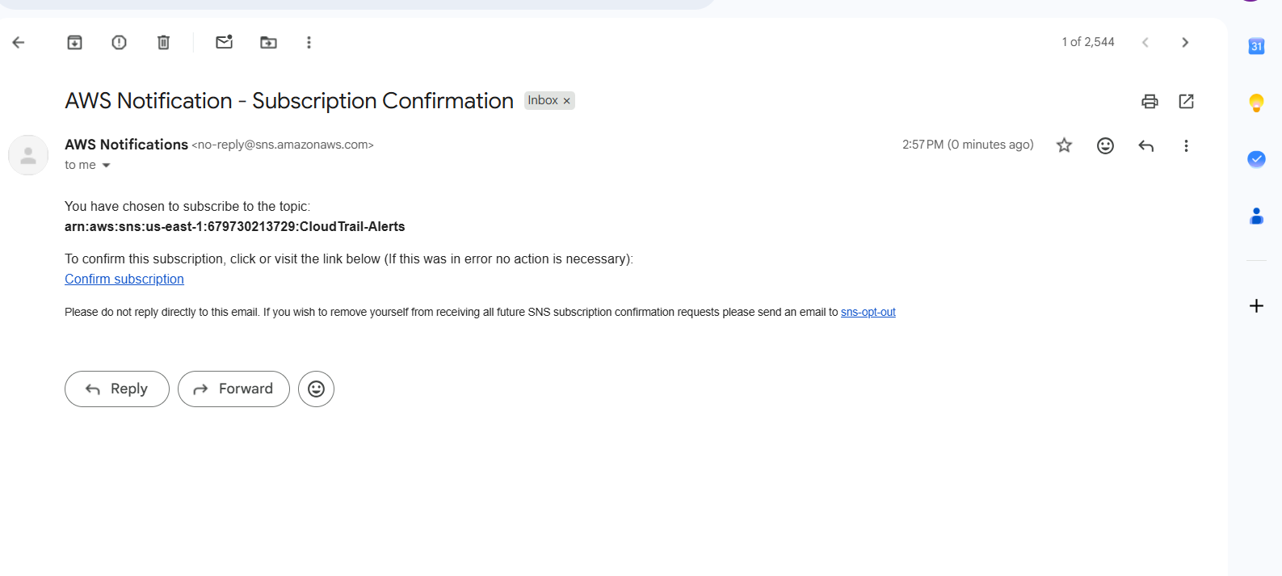 Clicked Create Subscription.
Purpose
The subscription defines where SNS should send notifications. In this task, notifications are sent to an email address.

Step 3: Confirm the Subscription
- Opened the Gmail inbox.
- Received an email from AWS SNS.
- Opened the email and clicked Confirm Subscription.
- Returned to SNS and verified that the subscription status changed to:
Confirmed
Purpose
AWS requires confirmation to ensure the email owner agrees to receive notifications from the SNS topic.
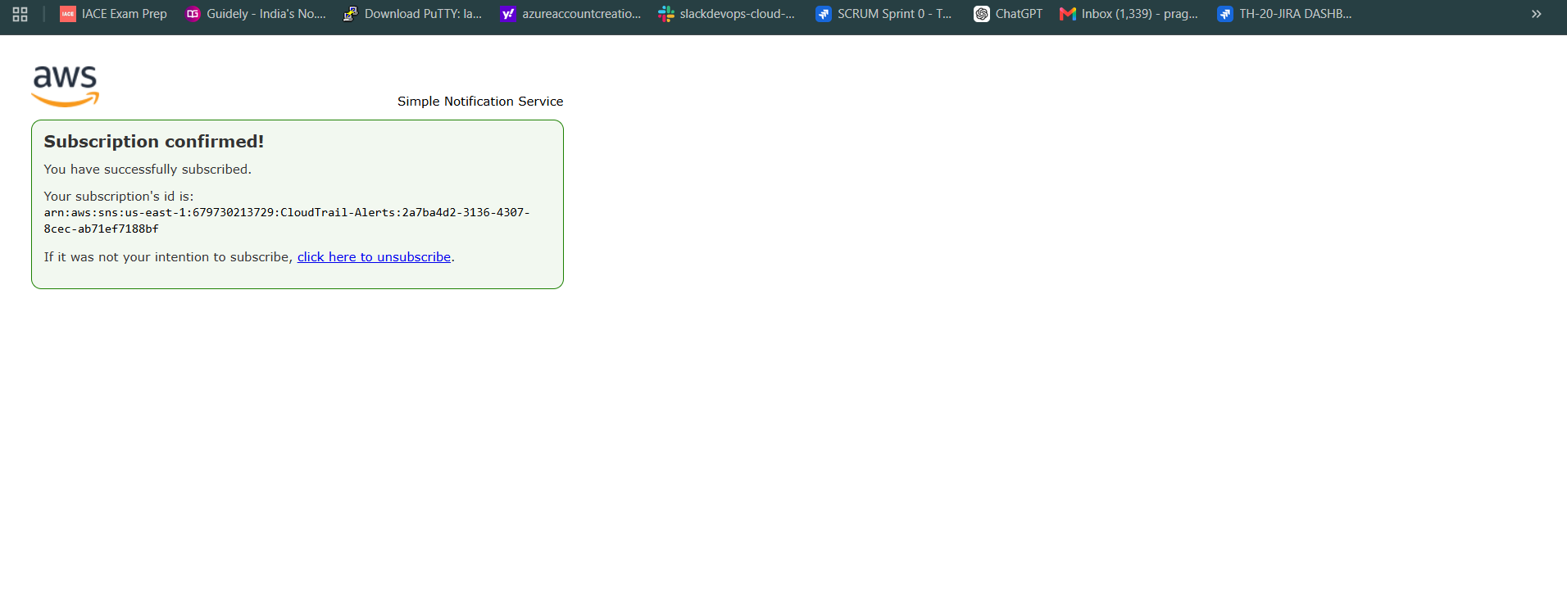 Step 4: Configure CloudTrail to Use SNS
- Opened AWS CloudTrail.
- Selected the existing trail:
cloudtrail-monitoring
- Clicked Edit.
- Scrolled to Additional Settings.
- Enabled:
SNS Notification Delivery
- Selected:
Existing SNS Topic
- Chose the SNS topic:
CloudTrail-Alerts
- Saved the changes.
Purpose
This configuration allows CloudTrail to send notifications to SNS whenever log files are delivered.
- 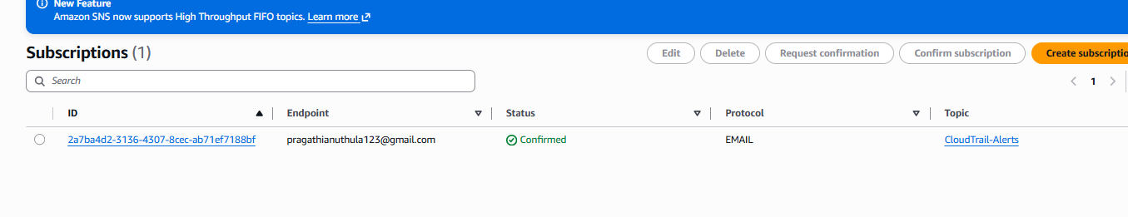 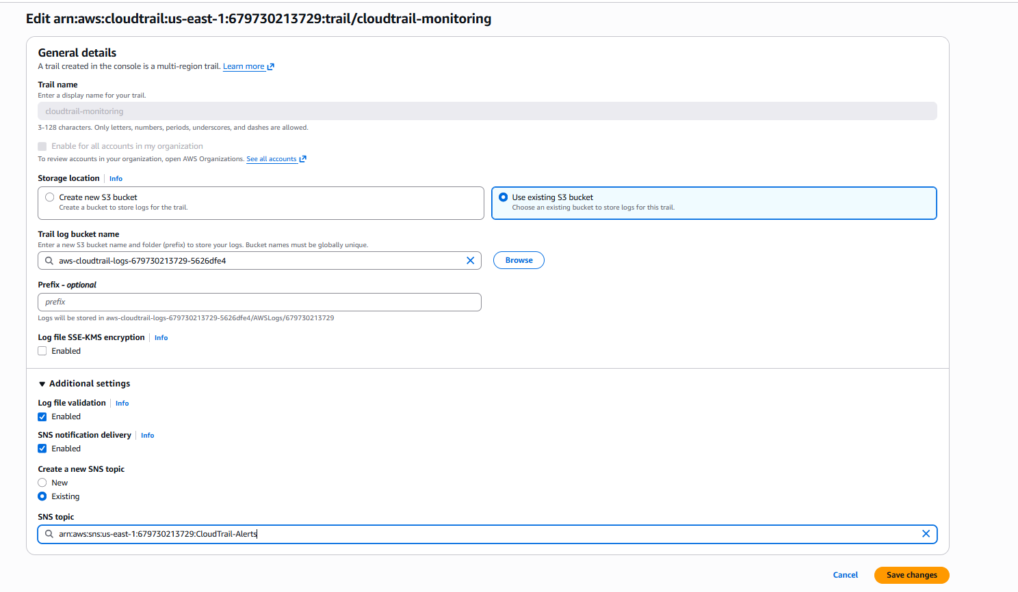 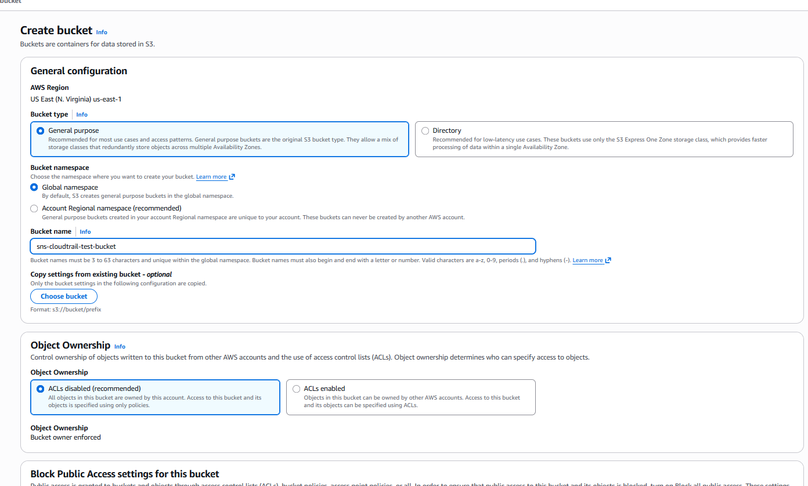 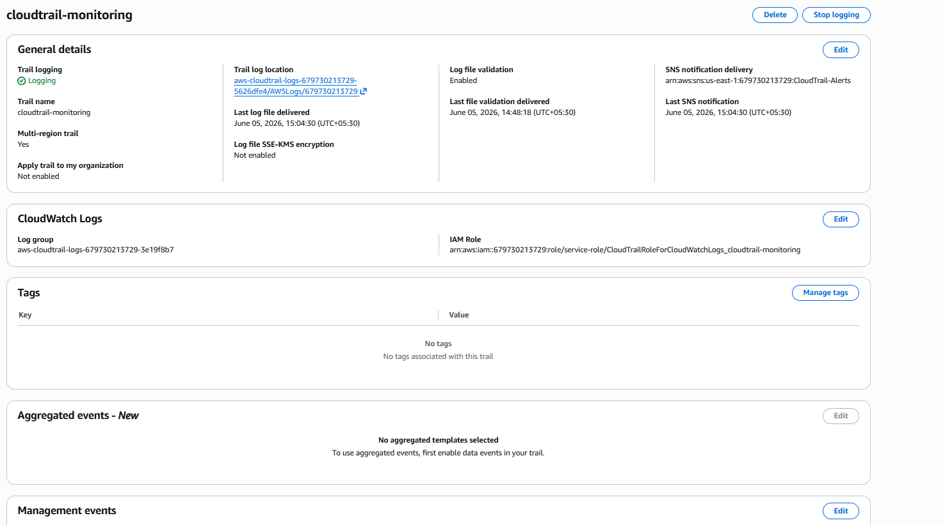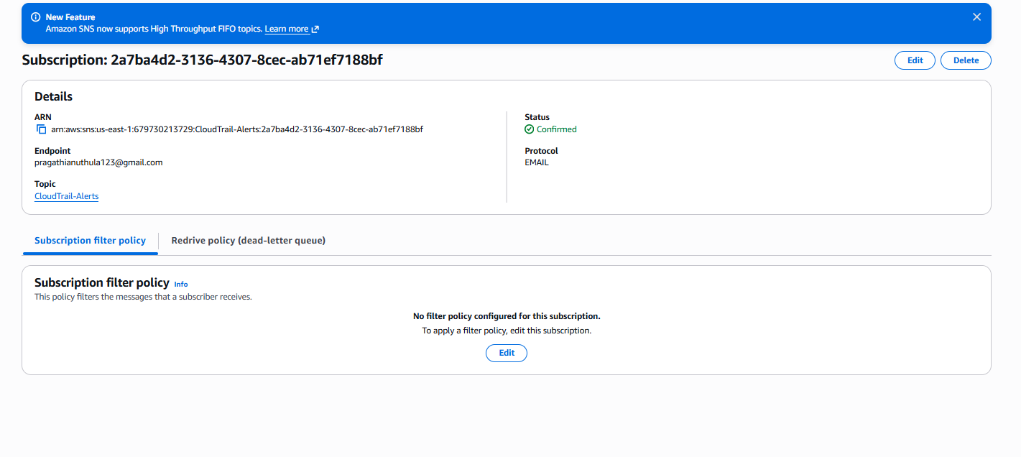 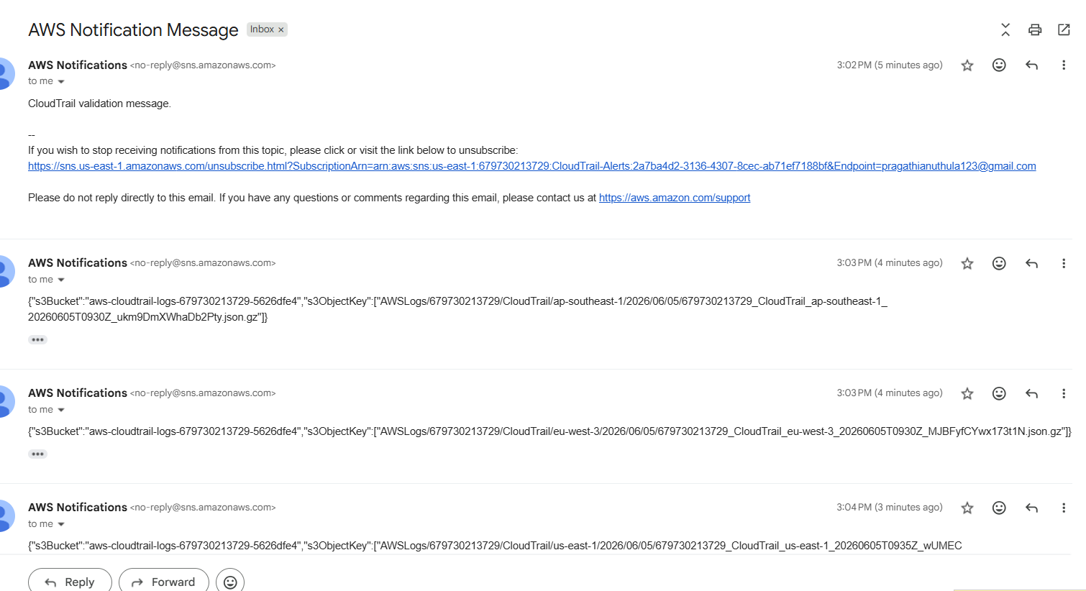 Verified that the email contained CloudTrail log delivery details such as:
s3Bucket : aws-cloudtrail-logs-679730213729-5626dfe4
s3ObjectKey : AWSLogs/679730213729/CloudTrail/...
Purpose
These notifications confirm that CloudTrail successfully delivered log files and SNS successfully forwarded the notification to the subscribed email address.

Architecture
CloudTrail
|
v
SNS Topic (CloudTrail-Alerts)
|
v
Email Subscription
|
v
pragathianuthula123@gmail.com

Result
Successfully configured Amazon SNS with AWS CloudTrail. Created an SNS topic, subscribed an email

Task 3: Configure CloudWatch Monitoring and Record CPU Utilization and Other EC2 Metrics
Objective
Configure Amazon CloudWatch to monitor an EC2 instance and collect performance metrics such as CPU utilization, network traffic, disk operations, and status checks. Create monitoring dashboards and alarms for performance tracking.

Step 1: Launch or Select an EC2 Instance
- Login to AWS Console.
- Open EC2 Dashboard.
- Click Instances.
- Select an existing EC2 instance.
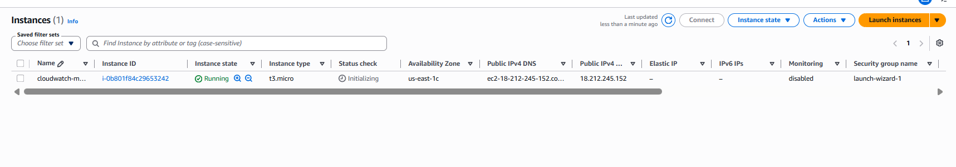 Step 2: Select EC2 Instance
- Go to EC2 → Instances.
- Select the instance.
- Click Actions.
- Click:
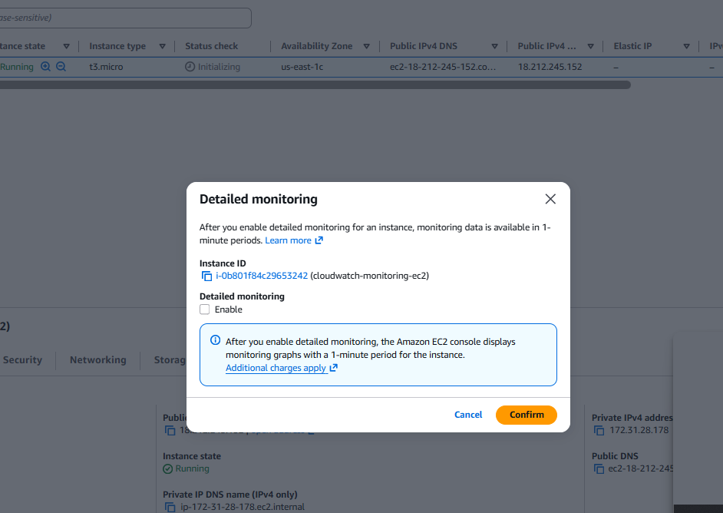Enable
- Click Confirm.
Part C: View EC2 Metrics in CloudWatch
Step 3: Open CloudWatch
- Search CloudWatch.
- Open CloudWatch.
- In the left menu, click:
Metrics
- Click:
All metrics
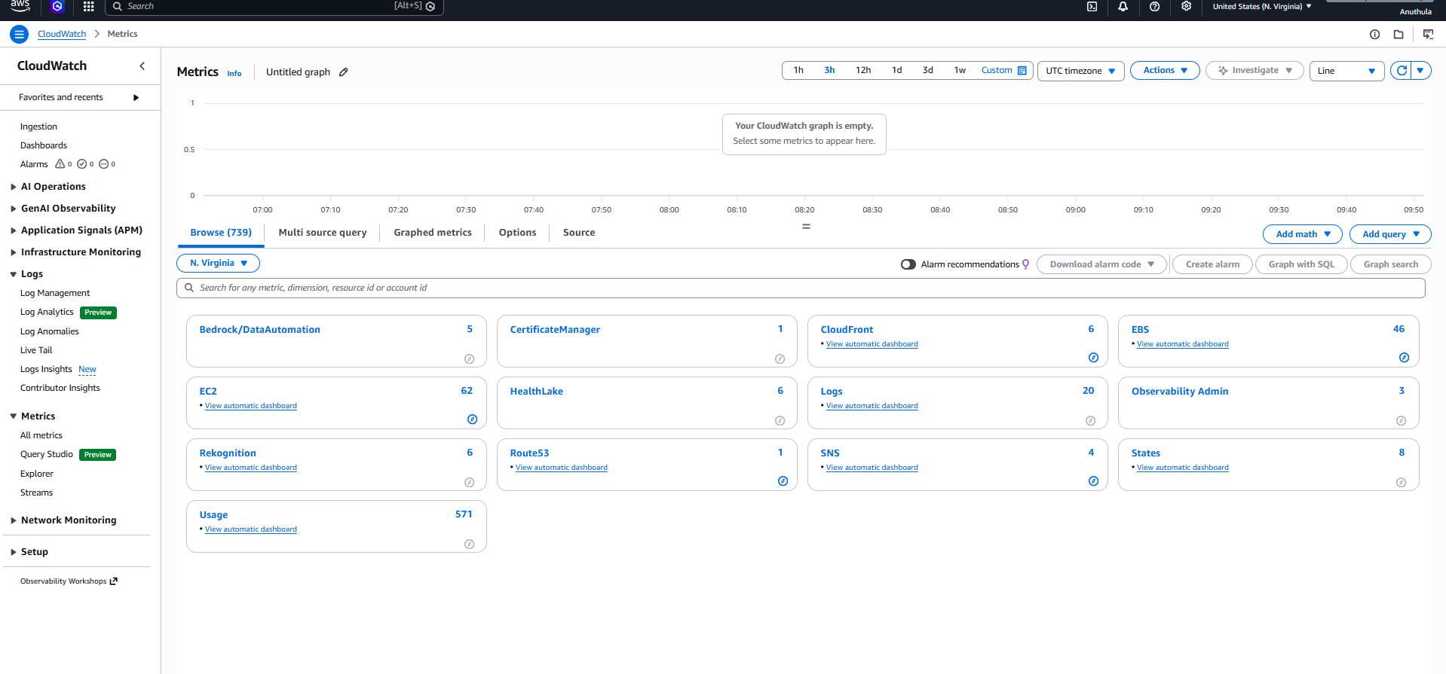 Step 4: Select EC2 Metrics
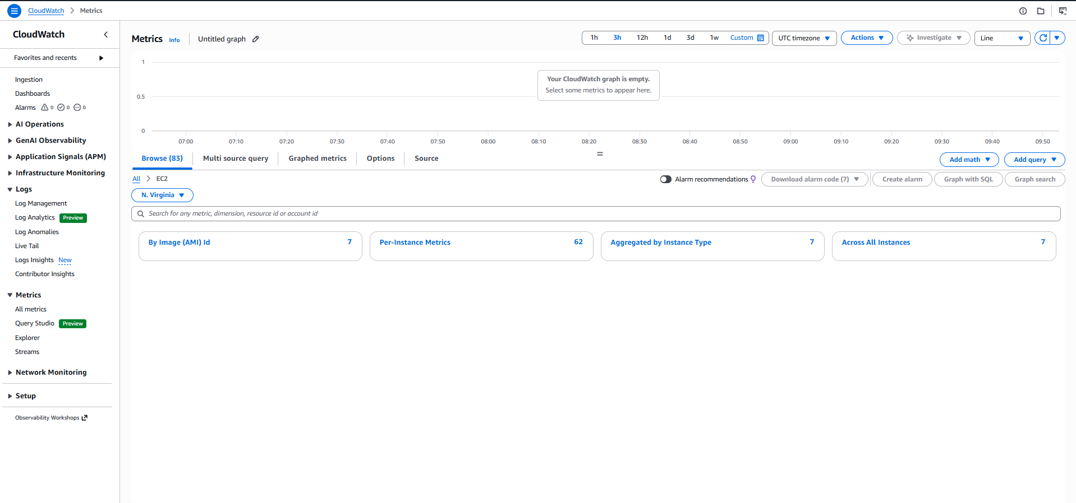Per-Instance Metrics
- Search your EC2 Instance ID.
Example:
i-xxxxxxxxxxxxxxxxx
- Select these metrics:
CPUUtilization
NetworkIn
NetworkOut
DiskReadOps
DiskWriteOps
StatusCheckFailed
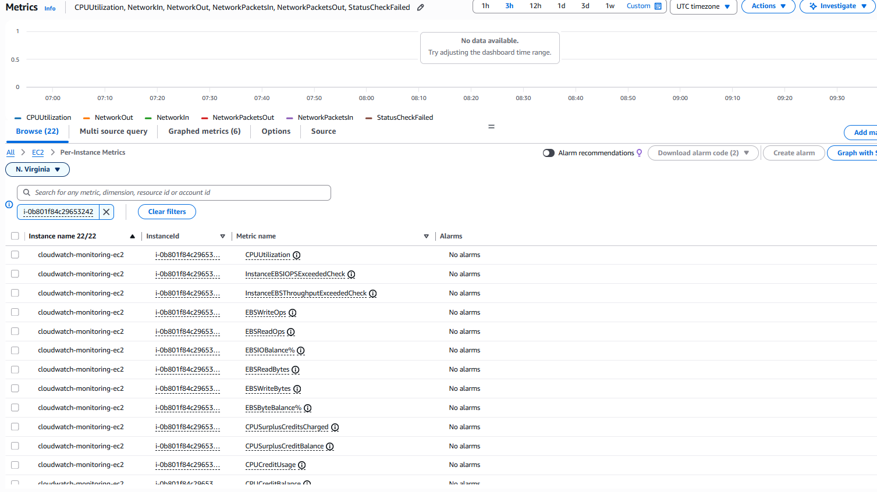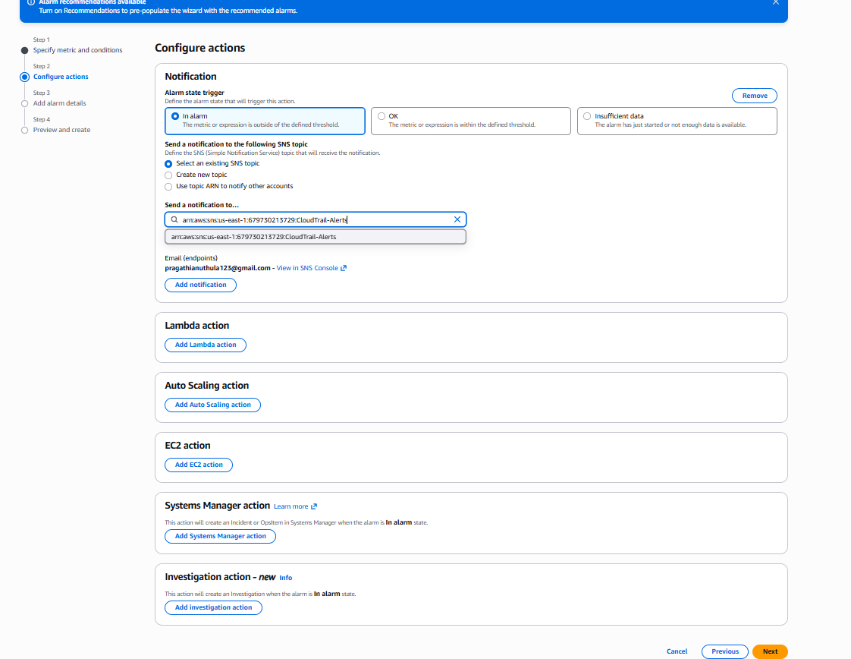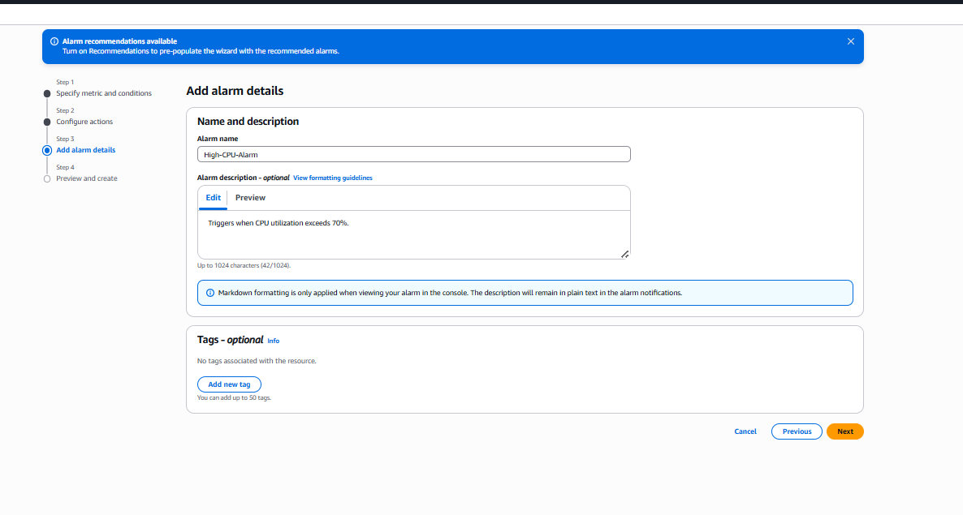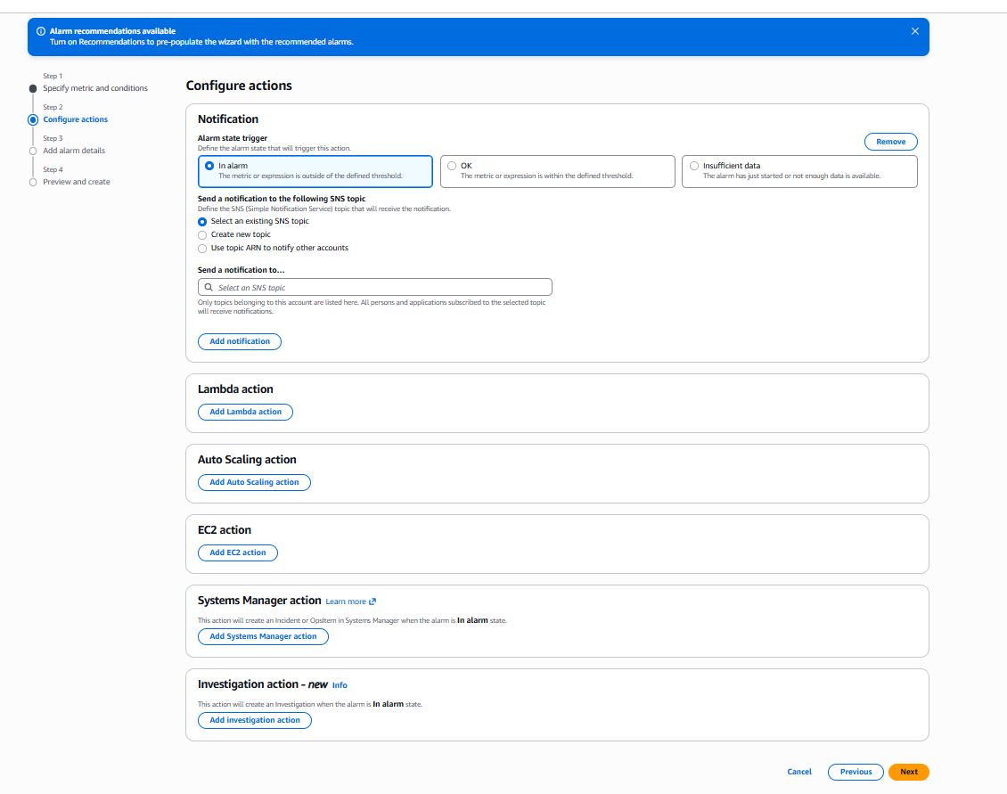

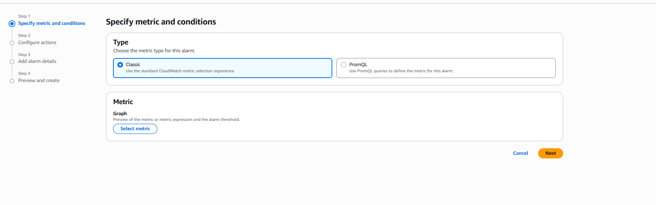 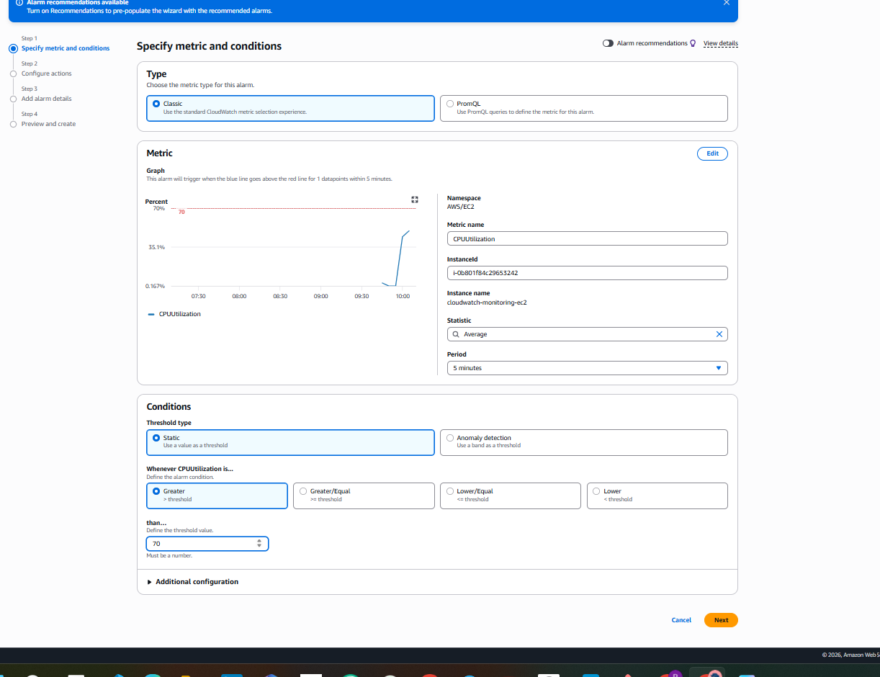 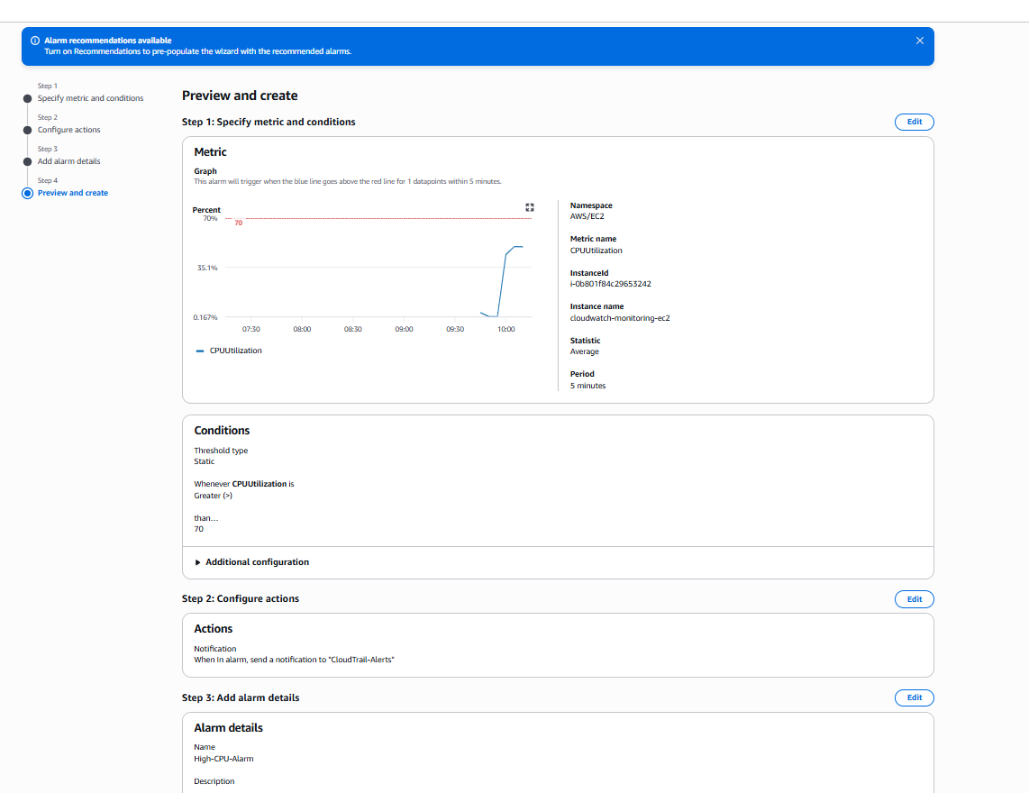 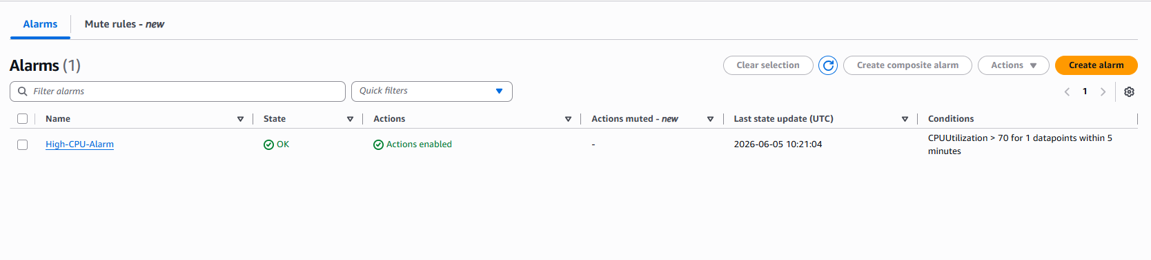 Step 3: View Instance Metrics
The following metrics were monitored:
- CPUUtilization
- NetworkIn
- NetworkOut
- NetworkPacketsIn
- NetworkPacketsOut
- StatusCheckFailed
These metrics help track CPU performance, network traffic, and instance health.

Step 4: Create a CloudWatch Alarm
- Selected the CPUUtilization metric.
- Clicked Create Alarm.
- Configured the following settings:
Setting | Value
Metric | CPUUtilization
Statistic | Average
Period | 5 Minutes
Threshold Type | Static
Condition | Greater Than
Threshold Value | 70
This configuration triggers the alarm whenever CPU utilization exceeds 70%.

Step 5: Configure Notification Actions
- Selected In Alarm state.
- Chose Select an Existing SNS Topic.
- Selected the SNS topic:
CloudTrail-Alerts
- This SNS topic was previously configured with an email subscription.
When the alarm enters the ALARM state, an email notification is automatically sent.

Step 6: Configure Alarm Details
Entered the following details:
Field | Value
Alarm Name | High-CPU-Alarm
Description | Triggers when CPU utilization exceeds 70%

Step 7: Review and Create Alarm
- Reviewed all alarm settings.
- Verified:
  - Metric: CPUUtilization
  - Threshold: Greater than 70%
  - SNS Topic: CloudTrail-Alerts
- Clicked Create Alarm.

Step 8: Verify Alarm Creation
- Navigated to CloudWatch → Alarms.
- Confirmed the alarm was successfully created.
Observed configuration:
Property | Value
Alarm Name | High-CPU-Alarm
State | OK
Actions | Enabled
Condition | CPUUtilization > 70 for 1 datapoint within 5 minutes
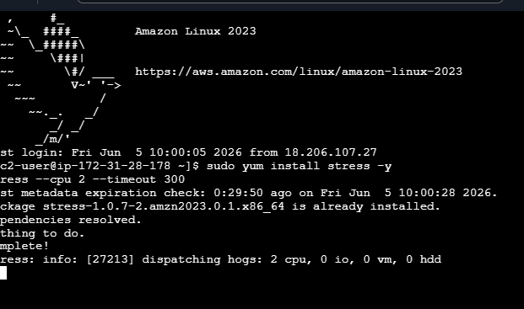
Result
Successfully configured Amazon CloudWatch monitoring for the EC2 instance. CloudWatch now collects and displays EC2 performance metrics and sends email alerts through Amazon SNS whenever CPU utilization exceeds 70%.

Task 4: Create a CloudWatch Alarm to Send Email Alerts When CPU Utilization Exceeds 70%
Objective
Configure an Amazon CloudWatch alarm to monitor EC2 CPU utilization and send an email notification using Amazon SNS whenever CPU utilization exceeds 70%.

Step 1: Open CloudWatch Service
- Sign in to the AWS Management Console.
- Search for CloudWatch in the Services search bar.
- Open Amazon CloudWatch.
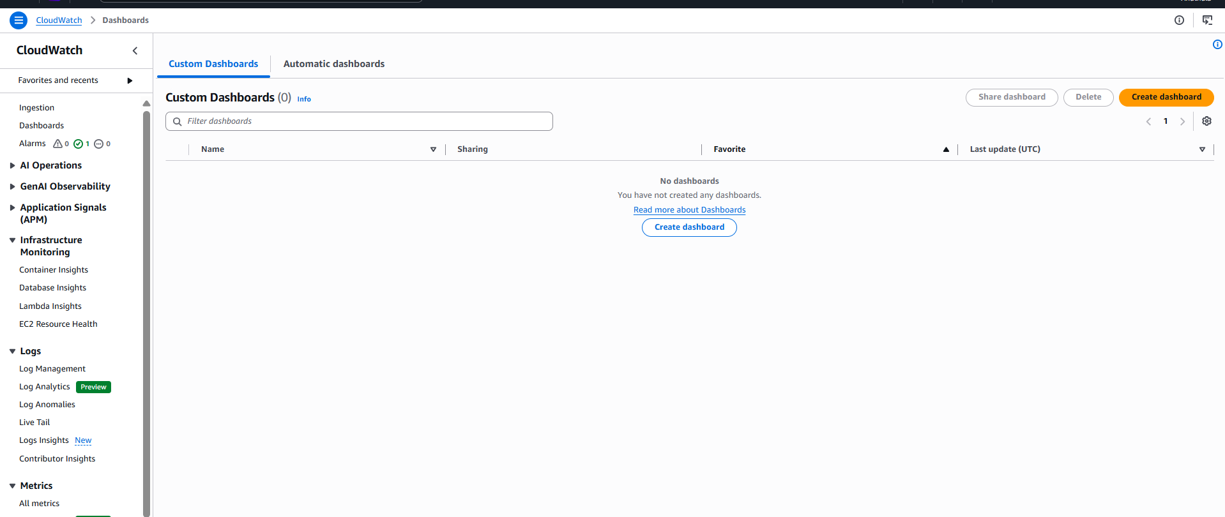Step 2: Navigate to Alarms
- In the left navigation pane, click Alarms.
- Click Create Alarm.
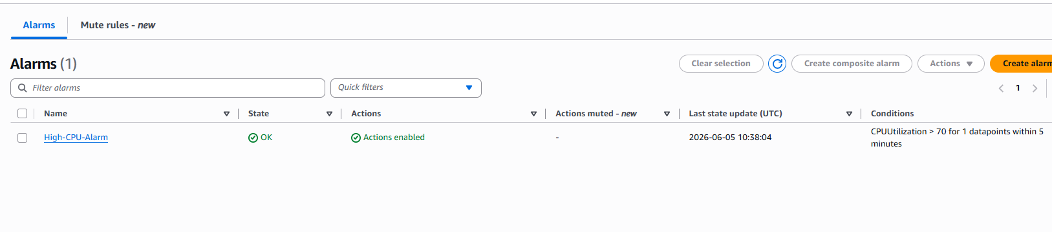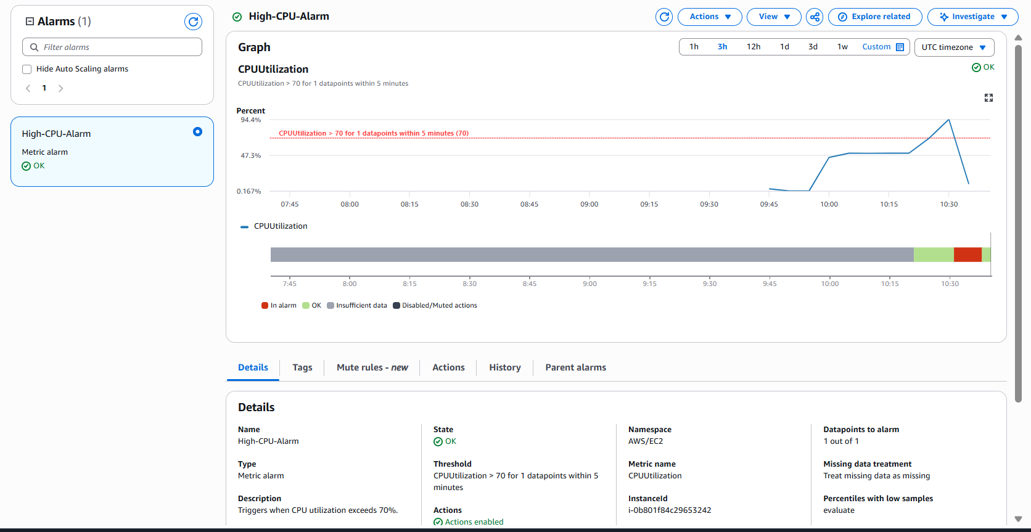
Step 3: Select Metric
- Click Select Metric.
- Choose:
EC2
→ Per-Instance Metrics
- Select your EC2 instance.
- Choose the metric:
CPUUtilization
- Click Select Metric.

Step 4: Configure Alarm Condition
Under Conditions:
- Statistic:
Average
- Period:
5 Minutes
- Threshold Type:
Static
- Whenever CPUUtilization is:
Greater than
- Threshold Value:
70
This means the alarm will trigger whenever CPU utilization exceeds 70%.

Step 5: Configure SNS Notification
Click Next.
Under Notification:
- Select:
In Alarm
- Select:
Use Existing SNS Topic
- Choose SNS Topic:
CloudTrail-Alerts
- Verify your email subscription is attached to the topic.

Step 6: Configure Alarm Details
- Alarm Name:
High-CPU-Alarm
- Description:
Sends an email alert when CPU utilization exceeds 70%.
- Click Next.

Step 7: Review and Create Alarm
- Review all settings.
- Click Create Alarm.
The CloudWatch alarm is now created successfully.
📸 Screenshot 7: Alarm Review Page

Step 8: Verify Alarm Creation
Navigate to:
CloudWatch
→ Alarms
Verify that:
High-CPU-Alarm
appears in the alarm list.
Initially, the state may show:
OK
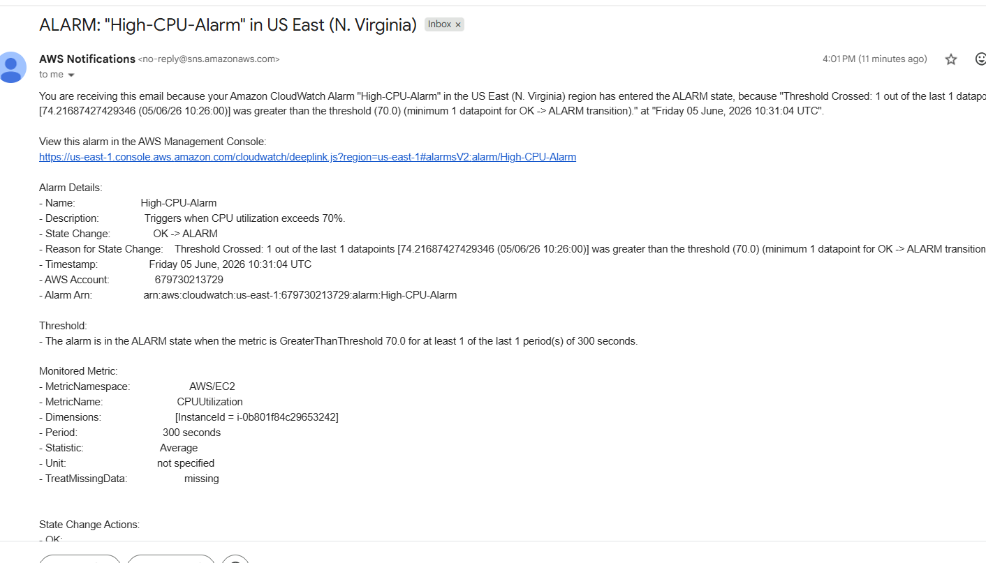Step 9: Generate CPU Load
To test the alarm:
- Connect to the EC2 instance using SSH.
- Run the following command:
yes > /dev/null &
- Run the command multiple times if required to increase CPU usage.
Example:
yes > /dev/null &
yes > /dev/null &
yes > /dev/null &
- Wait 5–10 minutes.
This increases CPU utilization above 70%.

Step 10: Verify Alarm State
Return to:
CloudWatch
→ Alarms
Verify that:
High-CPU-Alarm
changes from:
OK
to:
In Alarm

Task 5: Create a Dashboard and Monitor Tomcat Service with Email Alert
Step 1: Install and Start Tomcat
- Connect to the EC2 instance using SSH.
- Install Java.
- Download Apache Tomcat.
- Extract the Tomcat package.
- Rename the Tomcat directory.
- Start the Tomcat service.
Commands used:
cd /opt
sudo wget https://archive.apache.org/dist/tomcat/tomcat-9/v9.0.89/bin/apache-tomcat-9.0.89.tar.gz
sudo tar -xvzf apache-tomcat-9.0.89.tar.gz
sudo mv apache-tomcat-9.0.89 tomcat
sudo chmod +x /opt/tomcat/bin/*.sh
sudo /opt/tomcat/bin/startup.sh
Verify:
ps -ef | grep tomcat
📸 Screenshot 1: Tomcat Started Successfully

Step 2: Verify Tomcat in Browser
- Open Security Group.
- Add inbound rule:
Type: Custom TCP
Port: 8080
Source: 0.0.0.0/0
- Save Rules.
Open:
http://<Public-IP>:8080
Tomcat home page should open.
📸 Screenshot 2: Tomcat Home Page

Step 3: Install CloudWatch Agent
Install Agent:
sudo yum install amazon-cloudwatch-agent -y
Verify:
rpm -qa | grep amazon-cloudwatch-agent
📸 Screenshot 3: CloudWatch Agent Installed

Step 4: Create IAM Role
- Open IAM.
- Create Role.
- Select:
AWS Service
EC2
- Attach Policy:
CloudWatchAgentServerPolicy
- Create Role:
CloudWatchAgentRole
📸 Screenshot 4: IAM Role Created

Step 5: Attach IAM Role to EC2
- Open EC2.
- Select Instance.
- Actions → Security → Modify IAM Role.
- Select:
CloudWatchAgentRole
- Click Update IAM Role.
📸 Screenshot 5: IAM Role Attached

Step 6: Publish Tomcat Status Metric
Create monitoring script.
Example:
sudo vi /opt/tomcat-status.sh
Script checks Tomcat process and sends custom metric to CloudWatch.
Run:
sudo chmod +x /opt/tomcat-status.sh
sudo /opt/tomcat-status.sh
📸 Screenshot 6: Metric Published Successfully

Step 7: Verify Custom Metric
- Open CloudWatch.
- Click Metrics.
- Select:
Custom Namespaces
- Open:
TomcatMonitoring
- Verify metric:
TomcatStatus
📸 Screenshot 7: TomcatStatus Metric

Step 8: Create Dashboard
- Select TomcatStatus metric.
- Click:
Actions → Add to Dashboard
- Create Dashboard:
Tomcat-Dashboard
- Widget Type:
Line
- Click Add to Dashboard.
- Save Dashboard.
📸 Screenshot 8: Dashboard Created
📸 Screenshot 9: Tomcat Dashboard

Step 9: Create CloudWatch Alarm
- Select:
TomcatStatus
- Click:
Create Alarm
Configure:
Threshold Type: Static
Condition:
Lower/Equal
Threshold Value:
1
Meaning:
Tomcat Running = 1
Tomcat Stopped = 0
Alarm triggers when Tomcat stops.
📸 Screenshot 10: Alarm Condition Configuration

Step 10: Configure SNS Notification
- Select:
In Alarm
- Choose:
Select Existing SNS Topic
- Select:
CloudTrail-Alerts
- Click Next.
📸 Screenshot 11: SNS Topic Selected

Step 11: Add Alarm Details
Alarm Name:
Tomcat-Service-Down-Alarm
Description:
Send email notification when Tomcat service stops running.
Click:
Create Alarm
📸 Screenshot 12: Alarm Created Successfully

Step 12: Test Alarm
Stop Tomcat:
sudo /opt/tomcat/bin/shutdown.sh
Verify:
ps -ef | grep tomcat
No Tomcat process should appear.
Run:
sudo /opt/tomcat-status.sh
Wait 2–5 minutes.
CloudWatch Alarm changes:
OK → ALARM
📸 Screenshot 13: Alarm in ALARM State

Step 13: Verify Email Notification
- Open subscribed email inbox.
- Verify email notification received from AWS SNS.
Example:
Alarm Name:
Tomcat-Service-Down-Alarm
Reason:
Threshold Crossed
TomcatStatus <= 1
📸 Screenshot 14: Email Alert Received

Description
Created and configured Apache Tomcat on an Amazon EC2 instance and enabled monitoring using Amazon CloudWatch. Published a custom metric named TomcatStatus under the TomcatMonitoring namespace to track the Tomcat service health. Created a CloudWatch Dashboard (Tomcat-Dashboard) to visualize the service status in real time. Configured a CloudWatch Alarm to trigger when the Tomcat service stops running and integrated the alarm with Amazon SNS to send email notifications. Successfully validated the monitoring solution by stopping the Tomcat service and verifying both the CloudWatch alarm and email alert functionality.
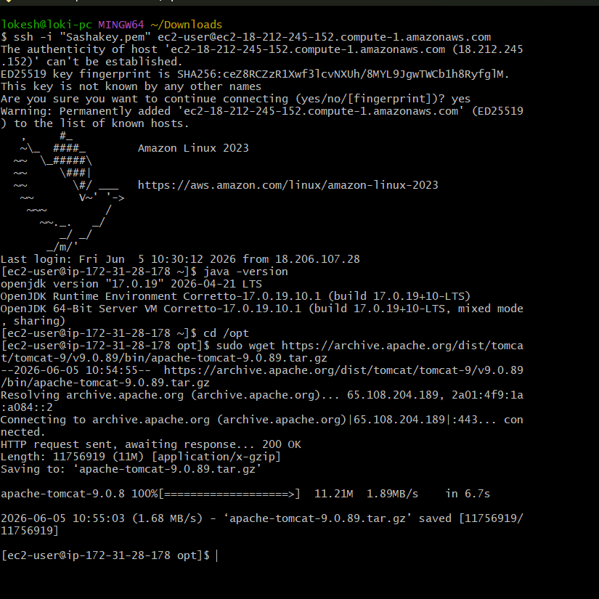 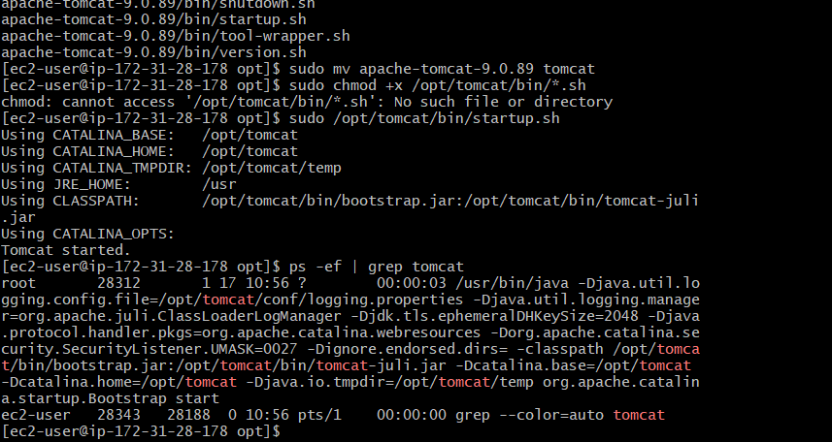 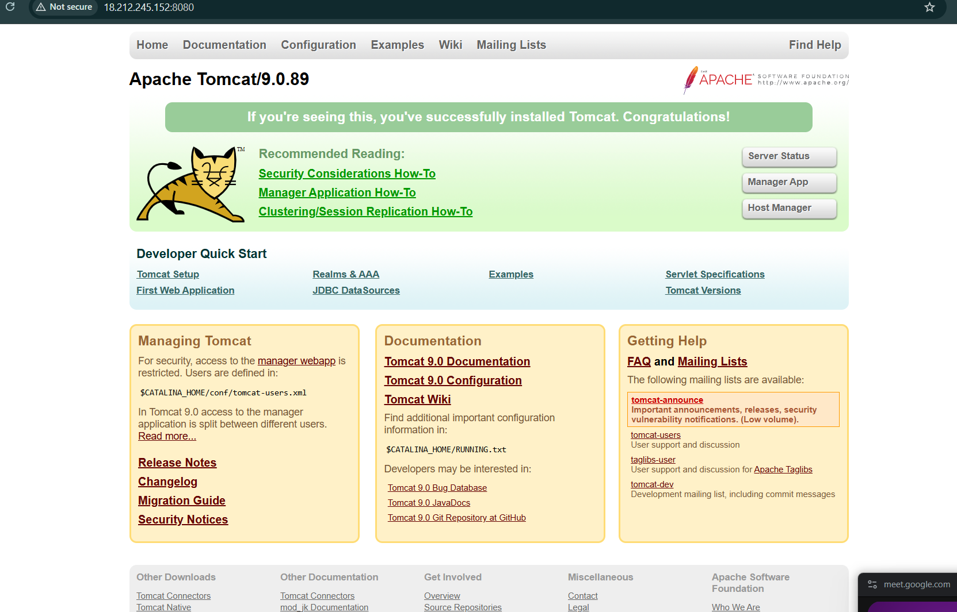 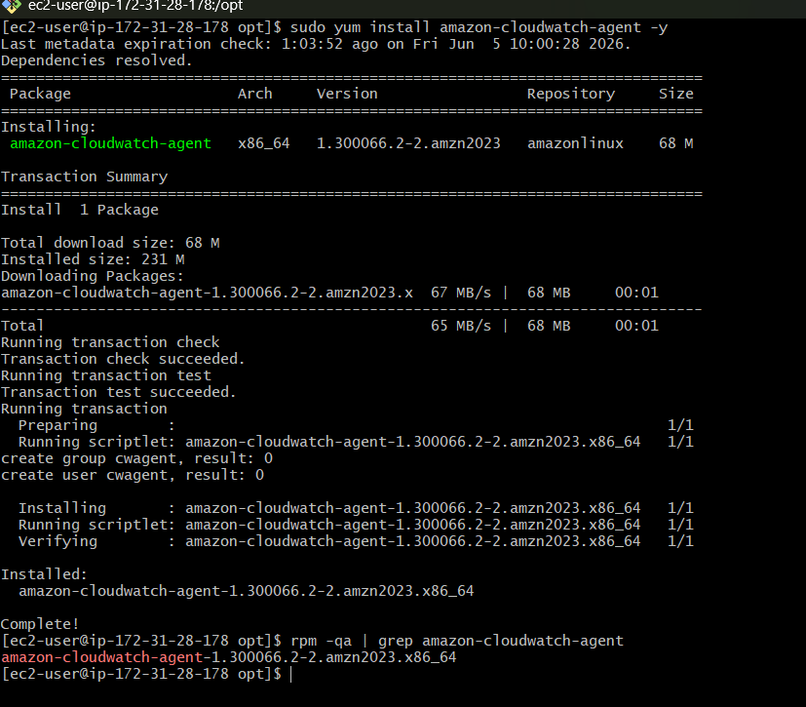 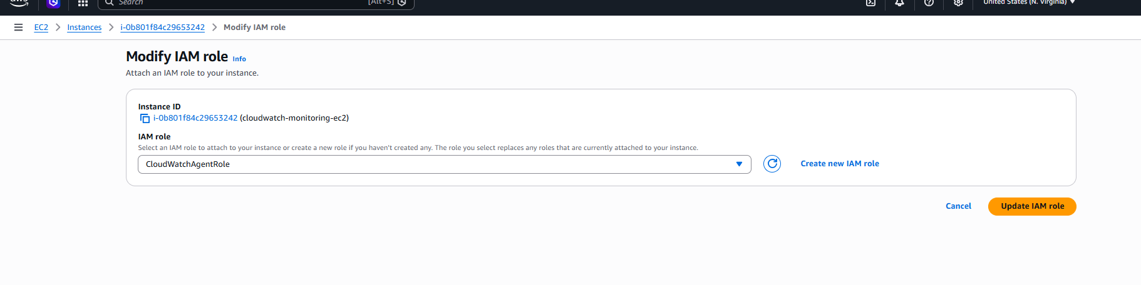 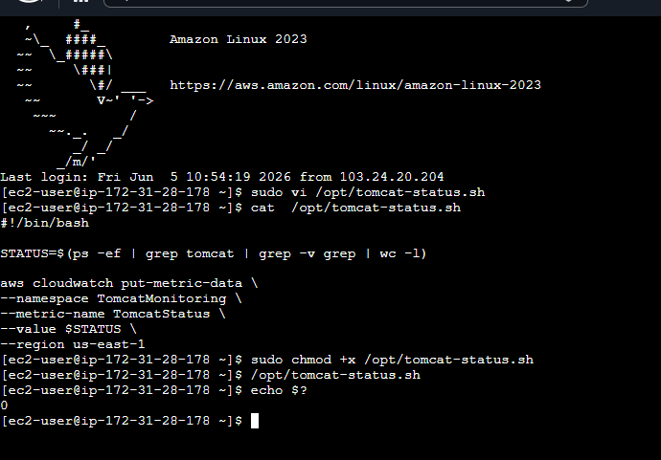 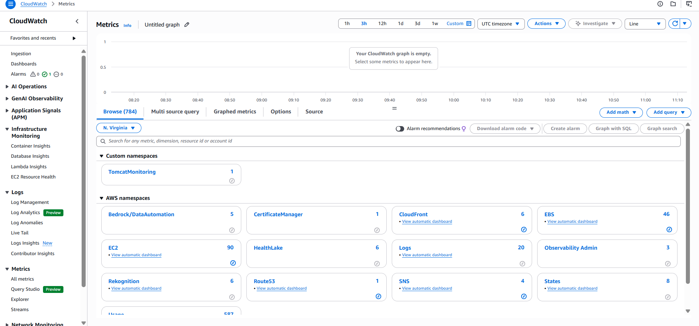 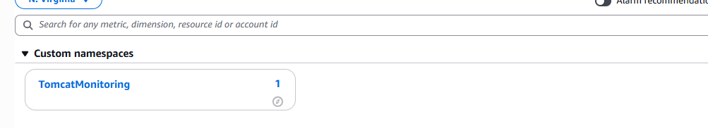 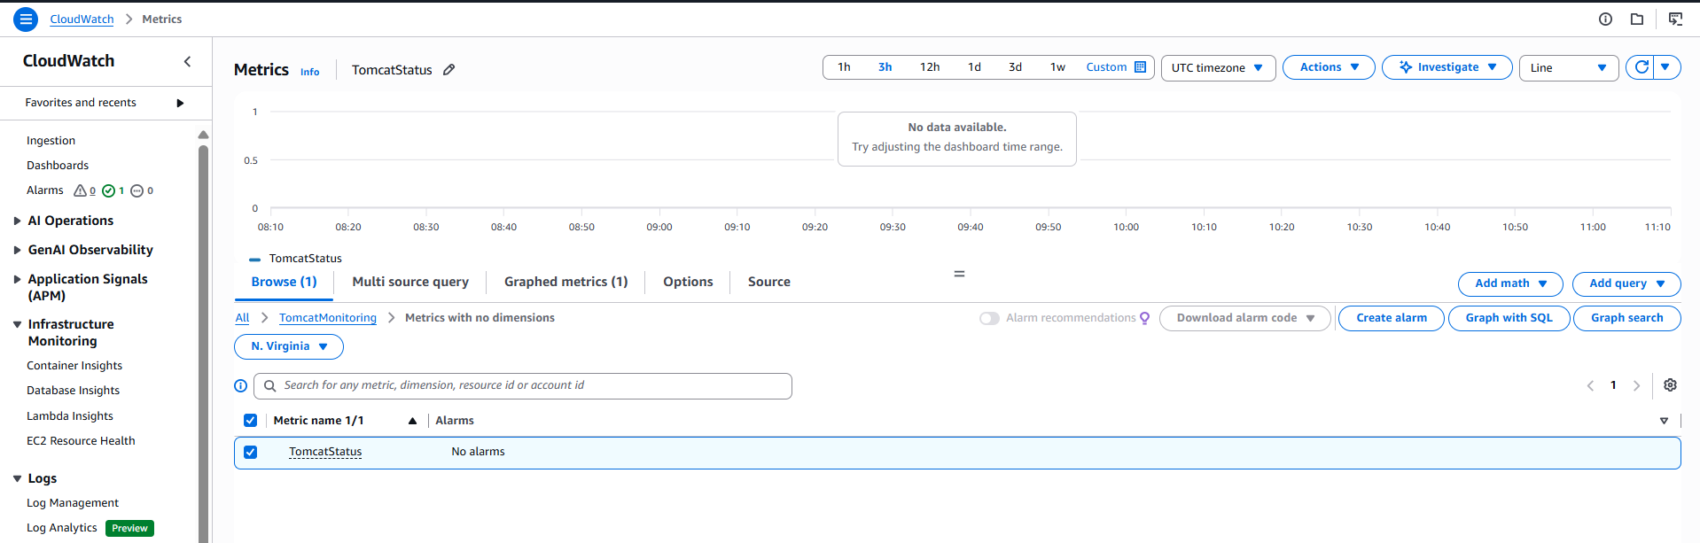 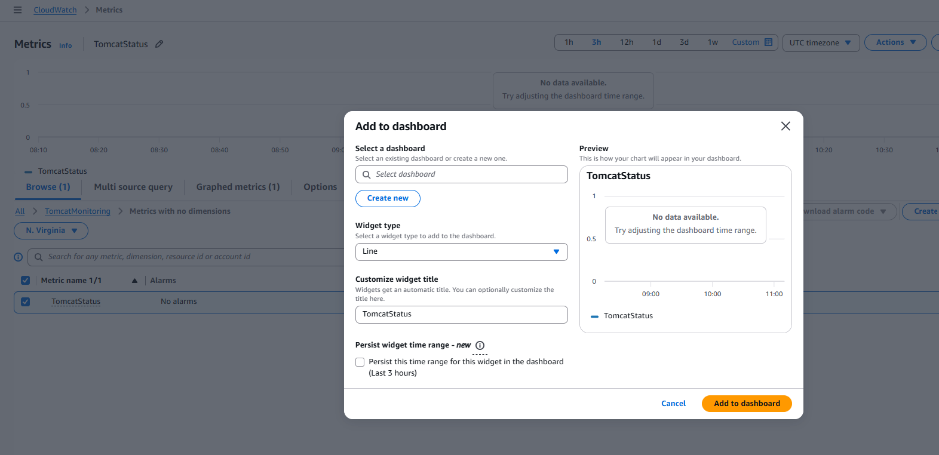 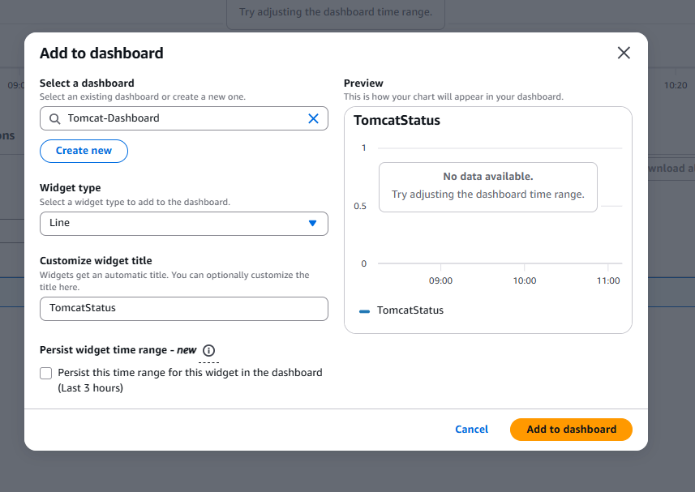 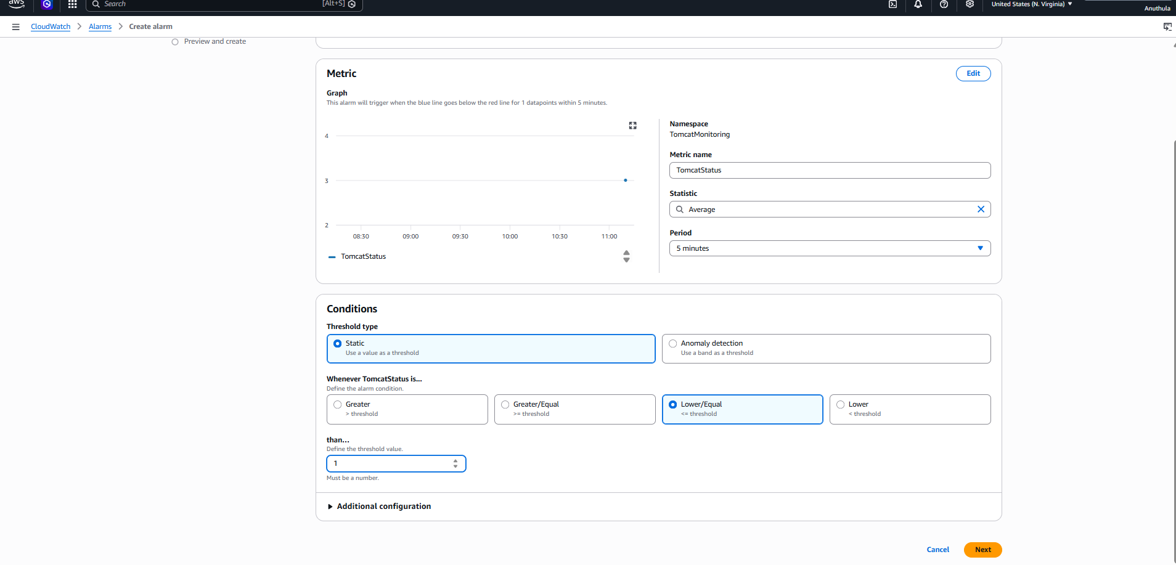 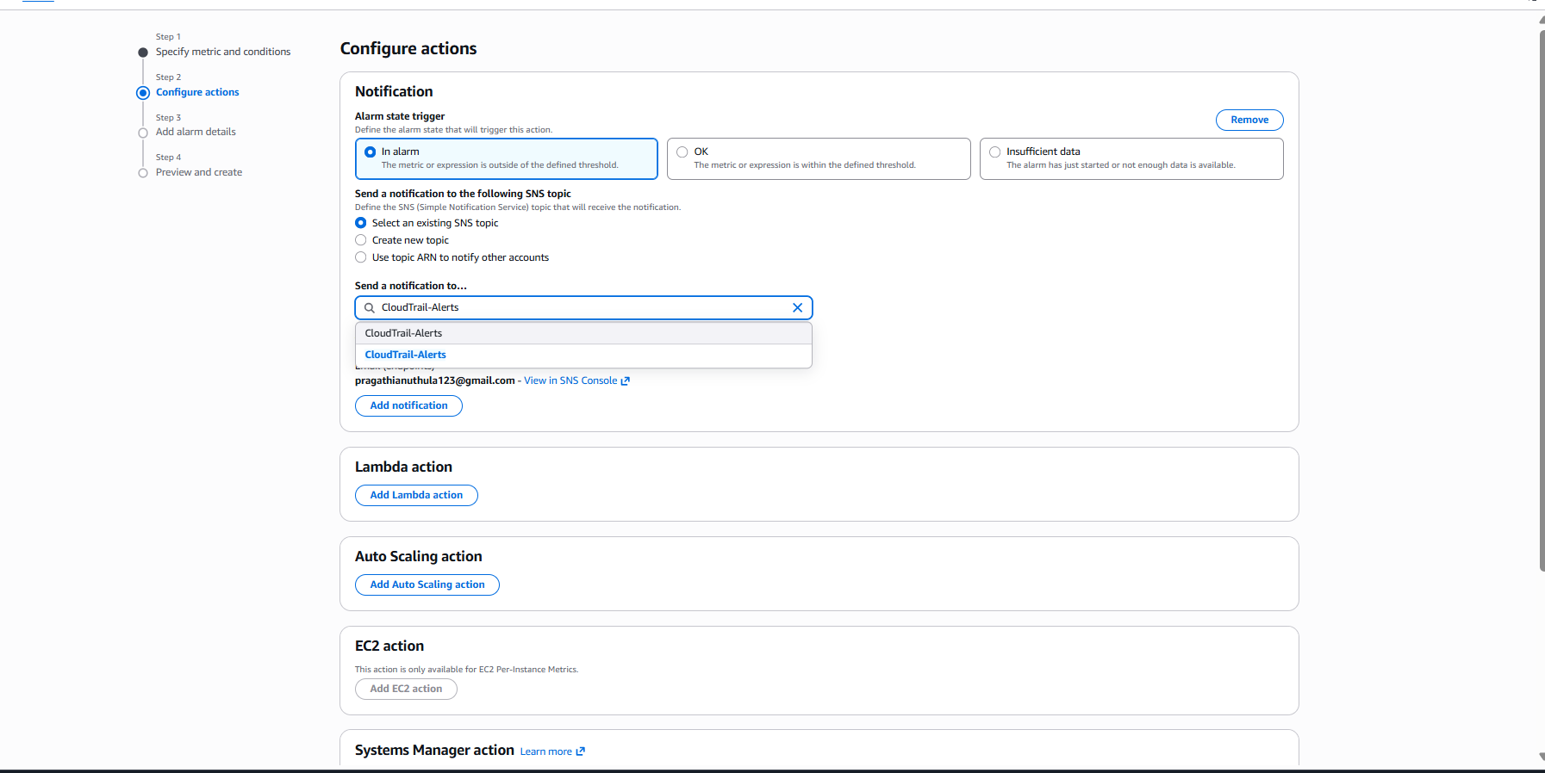 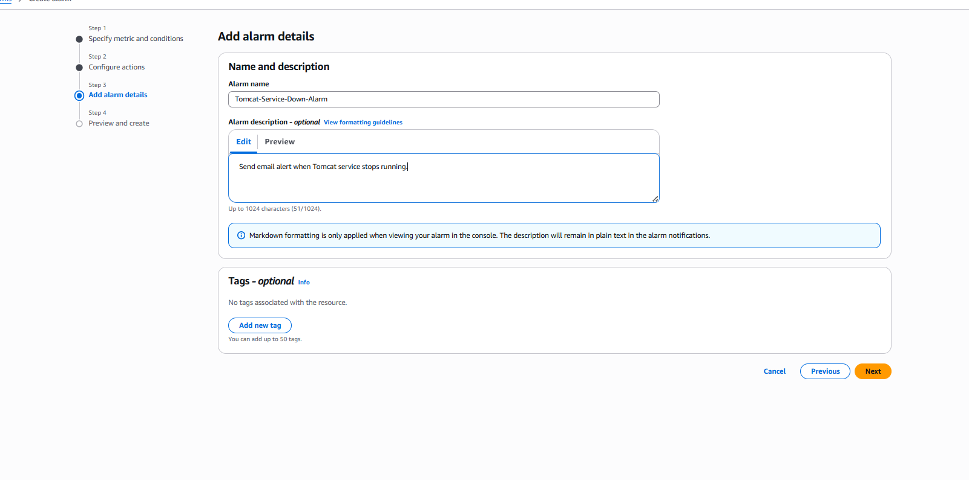 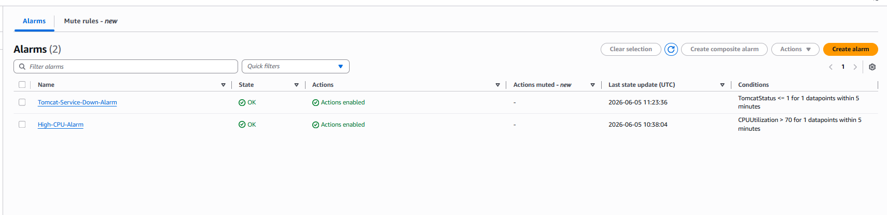 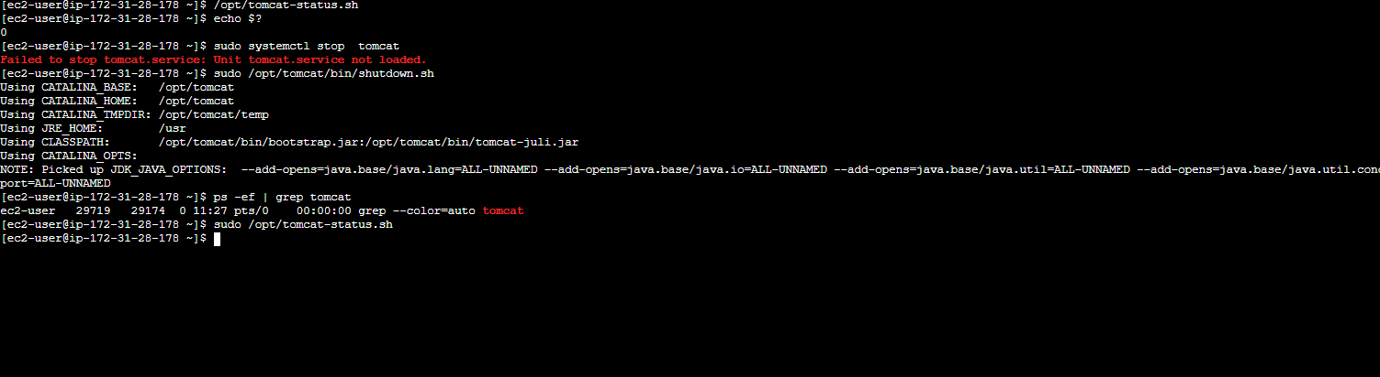 Task-6: Create a Dashboard and Monitor the Nginx Service to Send an Alert if Nginx is Not Running
Objective
To monitor the Nginx service running on an EC2 instance using Amazon CloudWatch. Configure a custom metric, create a dashboard, and send email notifications whenever the Nginx service stops.

Step 1: Launch and Configure EC2 Instance
- Created an Amazon EC2 instance using Amazon Linux 2023.
- Connected to the instance using SSH.
📸 Screenshot 1: EC2 Instance Running

Step 2: Install Nginx
Install Nginx.
sudo yum install nginx -y
Start Nginx service.
sudo systemctl start nginx
Enable Nginx service.
sudo systemctl enable nginx
Verify status.
sudo systemctl status nginx
Expected Output:
Active: active (running)
📸 Screenshot 2: Nginx Installed and Running

Step 3: Configure Security Group
Add an inbound rule.
Type | Port
HTTP | 80
Save the security group.
Open browser:
http://<EC2-Public-IP>
Verify Nginx welcome page appears.
📸 Screenshot 3: Nginx Welcome Page

Step 4: Install CloudWatch Agent
Install CloudWatch Agent.
sudo yum install amazon-cloudwatch-agent -y
Verify installation.
rpm -qa | grep amazon-cloudwatch-agent
📸 Screenshot 4: CloudWatch Agent Installed

Step 5: Create IAM Role
- Open IAM Console.
- Create Role.
- Trusted Entity = AWS Service.
- Use Case = EC2.
- Attach Policy:
CloudWatchAgentServerPolicy
- Create role:
CloudWatchAgentRole
- Attach role to EC2 instance.
EC2 → Actions → Security → Modify IAM Role
📸 Screenshot 5: IAM Role Attached

Step 6: Create Nginx Monitoring Script
Create script.
sudo vi /opt/nginx-status.sh
Paste:
#!/bin/bash
if systemctl is-active nginx > /dev/null
then
STATUS=1
else
STATUS=0
fi
aws cloudwatch put-metric-data \
--namespace NginxMonitoring \
--metric-name NginxStatus \
--value $STATUS \
--region us-east-1
Save and exit.
Give execute permission.
sudo chmod +x /opt/nginx-status.sh
Run script.
sudo /opt/nginx-status.sh
📸 Screenshot 6: Nginx Monitoring Script

Step 7: Verify CloudWatch Metric
Navigate to:
CloudWatch
→ Metrics
→ Custom Namespaces
→ NginxMonitoring
Verify metric:
NginxStatus
Value:
1 = Running
0 = Stopped
📸 Screenshot 7: Nginx Custom Metric

Step 8: Create CloudWatch Dashboard
Navigate to:
CloudWatch
→ Dashboards
→ Create Dashboard
Dashboard Name:
Nginx-Dashboard
Click:
Add Widget
Select:
NginxMonitoring
→ NginxStatus
Save dashboard.
📸 Screenshot 8: Dashboard Creation
📸 Screenshot 9: Nginx Dashboard

Step 9: Create CloudWatch Alarm
Navigate to:
CloudWatch
→ Metrics
→ NginxMonitoring
→ NginxStatus
→ Create Alarm
Configure:
Setting | Value
Metric | NginxStatus
Condition | Lower/Equal
Threshold | 0
Period | 1 Minute
Click Next.
Select SNS Topic:
CloudTrail-Alerts
Click Next.
Alarm Name:
Nginx-Service-Down-Alarm
Description:
Send email alert when Nginx service is not running.
Create Alarm.
📸 Screenshot 10: Alarm Configuration
📸 Screenshot 11: Alarm Created

Step 10: Test the Alarm
Stop Nginx.
sudo systemctl stop nginx
Verify:
sudo systemctl status nginx
Expected:
Active: inactive (dead)
Run monitoring script.
sudo /opt/nginx-status.sh
Wait 1–2 minutes.
Navigate to:
CloudWatch
→ Alarms
Verify alarm changes:
OK → ALARM
📸 Screenshot 12: Nginx Service Stopped
📸 Screenshot 13: Alarm State Changed to ALARM

Step 11: Verify Email Notification
Open subscribed email inbox.
Received email from AWS SNS.
Example:
ALARM: "Nginx-Service-Down-Alarm"
Reason:
Threshold Crossed:
NginxStatus was less than or equal to 0.
📸 Screenshot 14: Email Notification Received

Result
Successfully configured Amazon CloudWatch to monitor the Nginx service running on an EC2 instance. Created a custom dashboard, configured CloudWatch alarms, and integrated SNS email notifications to automatically alert administrators whenever the Nginx service stops running

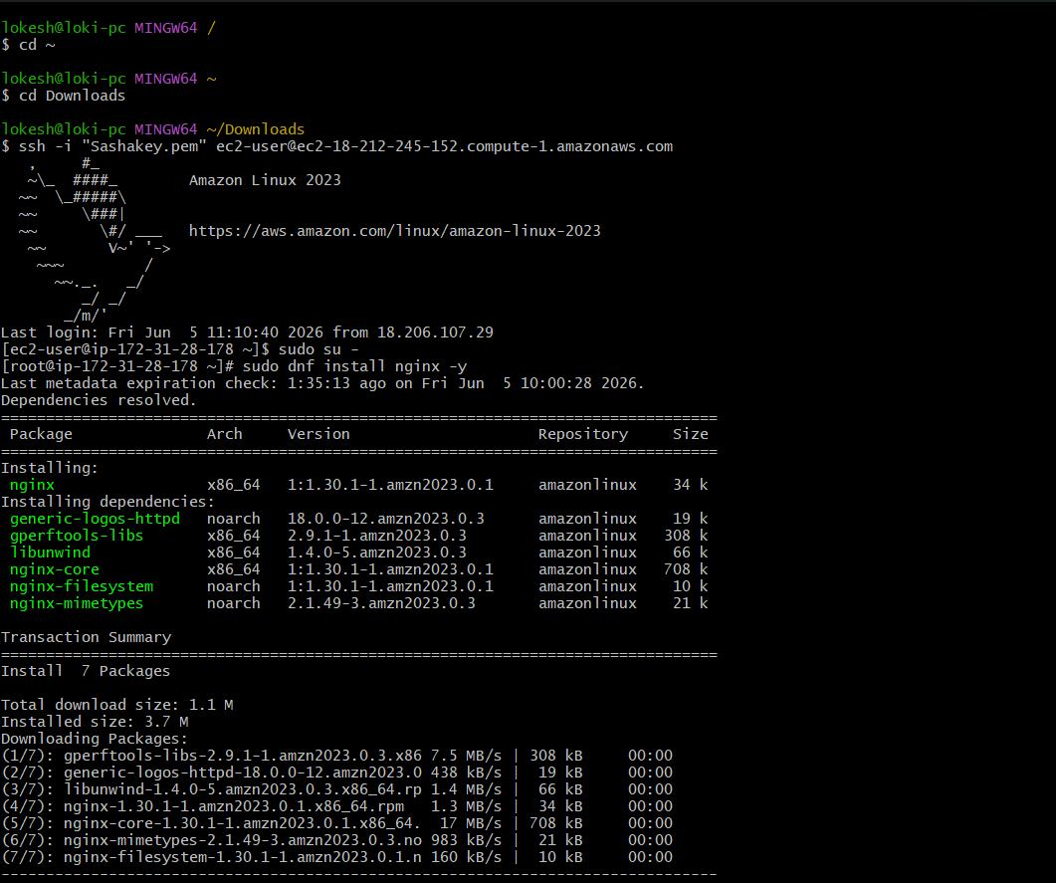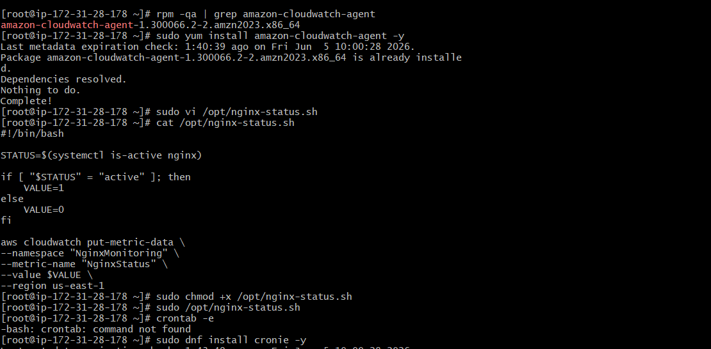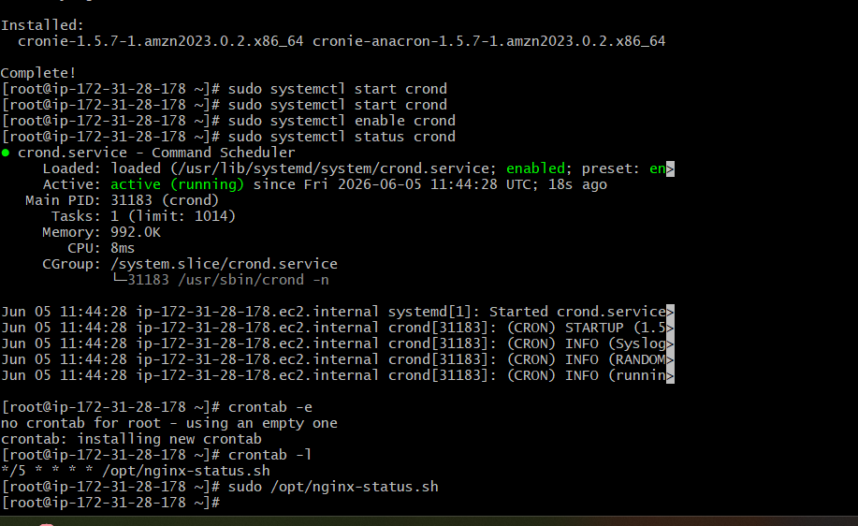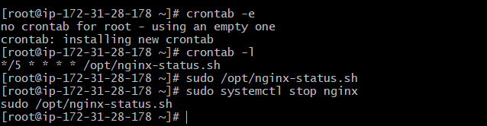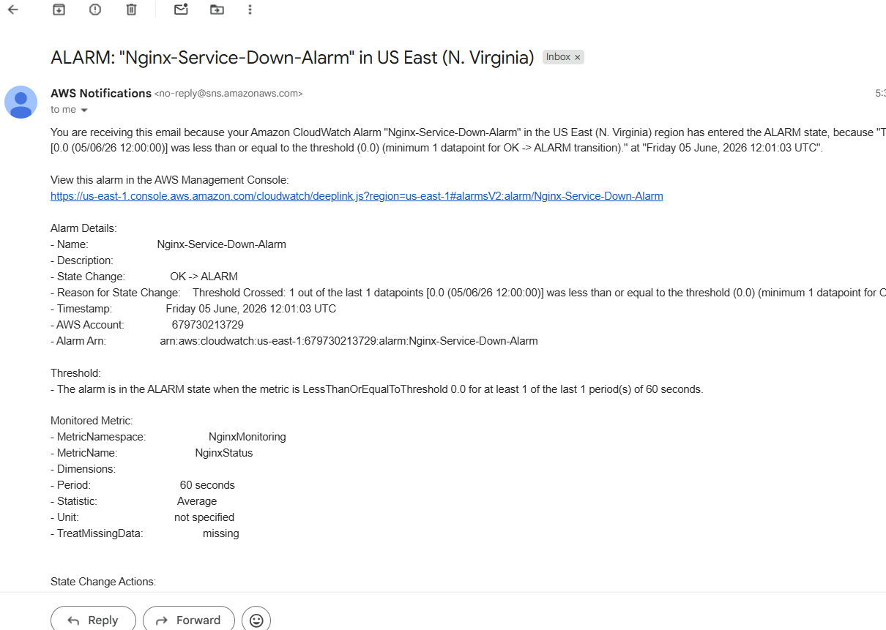

6---
